IBRASAL INVEST
Agricultural Commodity Export & Trade Platform
A complete Laravel website + CMS for Nigerian agro-export businesses
Built by SENUX Media
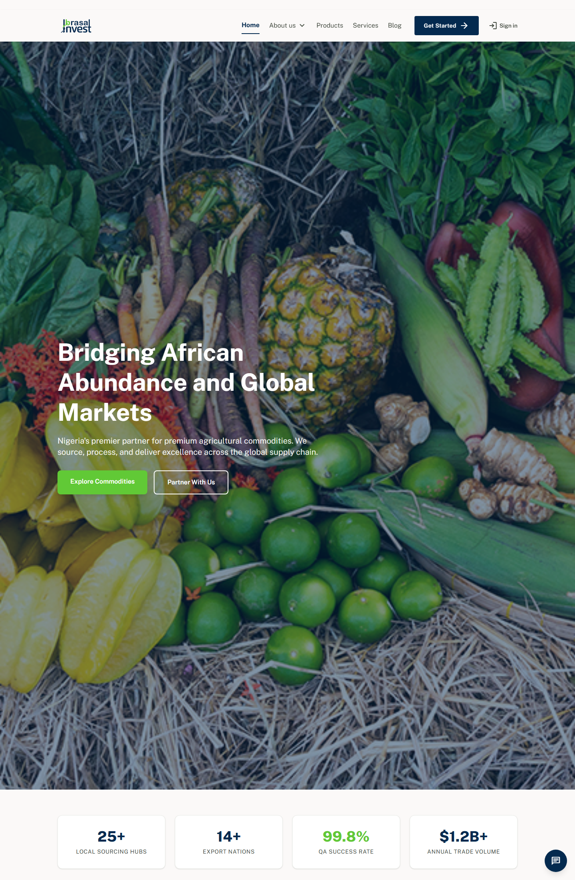
Homepage — fully editable hero carousel, commodities, value chain & more
Product Documentation & Buyer's Guide
Version 1.0 · Laravel 13 · PHP 8.3

Table of Contents

1. What Is Ibrasal Invest?
Ibrasal Invest is a complete, production-ready web platform built for agricultural commodity exporters — designed first and foremost for the Nigerian agro-export market. It combines a premium corporate marketing website, an editable content management system (CMS), a product catalogue with a built-in quote/order request flow, a customer portal, a staff portal, and a full admin/ERP back office in a single Laravel application.
Rather than a static template, every public page is built from editable “sections”, so the site owner can change text, images, statistics, cards and calls-to-action from the admin panel — no developer required. It ships with bilingual support (English & French), SEO controls, a live chat widget, a blog, and a newsletter.

Who It Is For
- Agricultural exporters & trading houses sourcing commodities (ginger, cashew, sesame, soybean, hibiscus, shea, etc.) for international buyers.
- Cooperatives and aggregators that want a professional online presence plus an inquiry/order pipeline.
- Agribusiness consultants and farm enterprises needing a marketing site with a back-office to manage farms, crops, livestock, inventory, tasks and finance.
- Developers / agencies who want a well-structured Laravel codebase they can rebrand and resell to agribusiness clients.

2. How It Works
The platform is organised into four connected areas, all sharing one database and one design system:
- Public website — The marketing front end: home, marketplace/products, services, about (with Our History, Our Team), blog, contact, privacy & terms. Visitors browse commodities and submit quote/order requests.
- Customer Portal — Buyers log in to track their orders, view order detail and download receipts.
- Staff Portal — Field/operations staff manage day-to-day farm operations — tasks, crops, livestock and inventory.
- Admin / ERP — The owner manages everything: page content, products, orders, customers, inquiries, blog, team, testimonials, media, settings, SEO, chat, notifications, farms, finance and more.

The Order / Quote Request Flow
- A buyer browses the Marketplace and opens a product (e.g. Dried Ginger).
- On the product page they enter a quantity and pick a unit (kg, tonne, bags, container — defined per-product by the admin), plus destination and notes.
- They submit the form, which creates an Inquiry record and fires an in-app admin notification (and email if SMTP is configured).
- The admin reviews the inquiry in Admin → Inquiries, responds, and can convert it into an Order with tracking.
- The customer follows the order in their Portal and downloads a receipt.
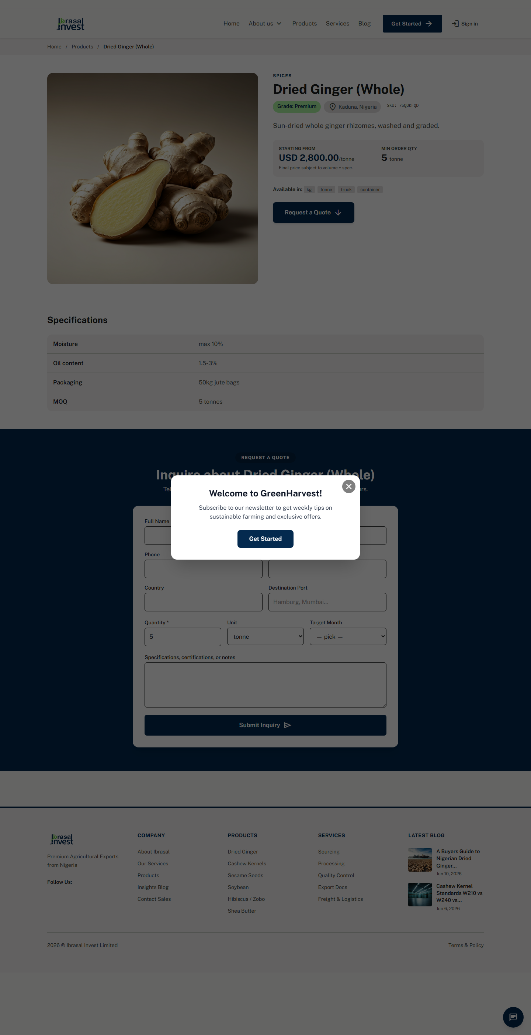
Product page — buyer chooses quantity & unit, then requests a quote

The “Everything Editable” Page Builder
Each public page is composed of reorderable sections managed in Admin → Page Sections. Section types include hero banners, stat cards, bento grids, image galleries, timelines, value-chain stages, team cards, legal/accordion blocks, info cards and more. The site owner edits headings, body text, images (upload or URL), icons, colours, buttons and card items — and can show/hide or reorder any block.
Hero banners and sliders are managed in a dedicated Hero area that supports image upload and multiple rotating slides.

3. Key Features
Area | What you get
Editable CMS | Every public page built from reorderable, fully-editable sections — text, images, icons, colours, buttons, cards.
Product Catalogue | Unlimited products with images, specifications, grade, origin, price/unit, min order qty and admin-defined units.
Quote / Order Flow | Built-in inquiry form per product; admin converts inquiries into tracked orders.
Customer Portal | Buyer login, order list, order detail, printable receipts.
Staff Portal | Tasks, crops, livestock and inventory management for operations staff.
Admin / ERP | Dashboard, products, orders, customers, inquiries, blog, services, team, testimonials, stats, projects, media library, farms, crops, livestock, inventory, tasks, finance, menus, popups, banners, galleries.
Blog & Newsletter | Categorised blog with featured post, single-post layout, and a working newsletter signup.
Live Chat Widget | Visitor chat with an admin inbox (conversations + messages).
SEO & Settings | Per-page SEO meta, company branding (logo, colours), contact details, social links.
Bilingual (EN/FR) | Locale switching with a fallback locale.
Roles & Security | Admin, staff and customer roles with middleware-protected areas and Laravel authentication.

4. Page-by-Page Walkthrough

4.1 Homepage
A cinematic hero carousel (managed in the Hero area) leads into editable blocks: key statistics, core commodities (pulled from the product catalogue), the “Ibrasal Advantage”, a value-chain image bento, services, testimonials, market insights (latest blog posts), accreditation partners and a newsletter signup.

4.2 Marketplace / Products
A bento-style catalogue with category filter chips and live search. Each product card shows technical specifications and a quote button; a bulk-quote panel sits at the bottom. Clicking a product opens the detail page with the order/quote form.
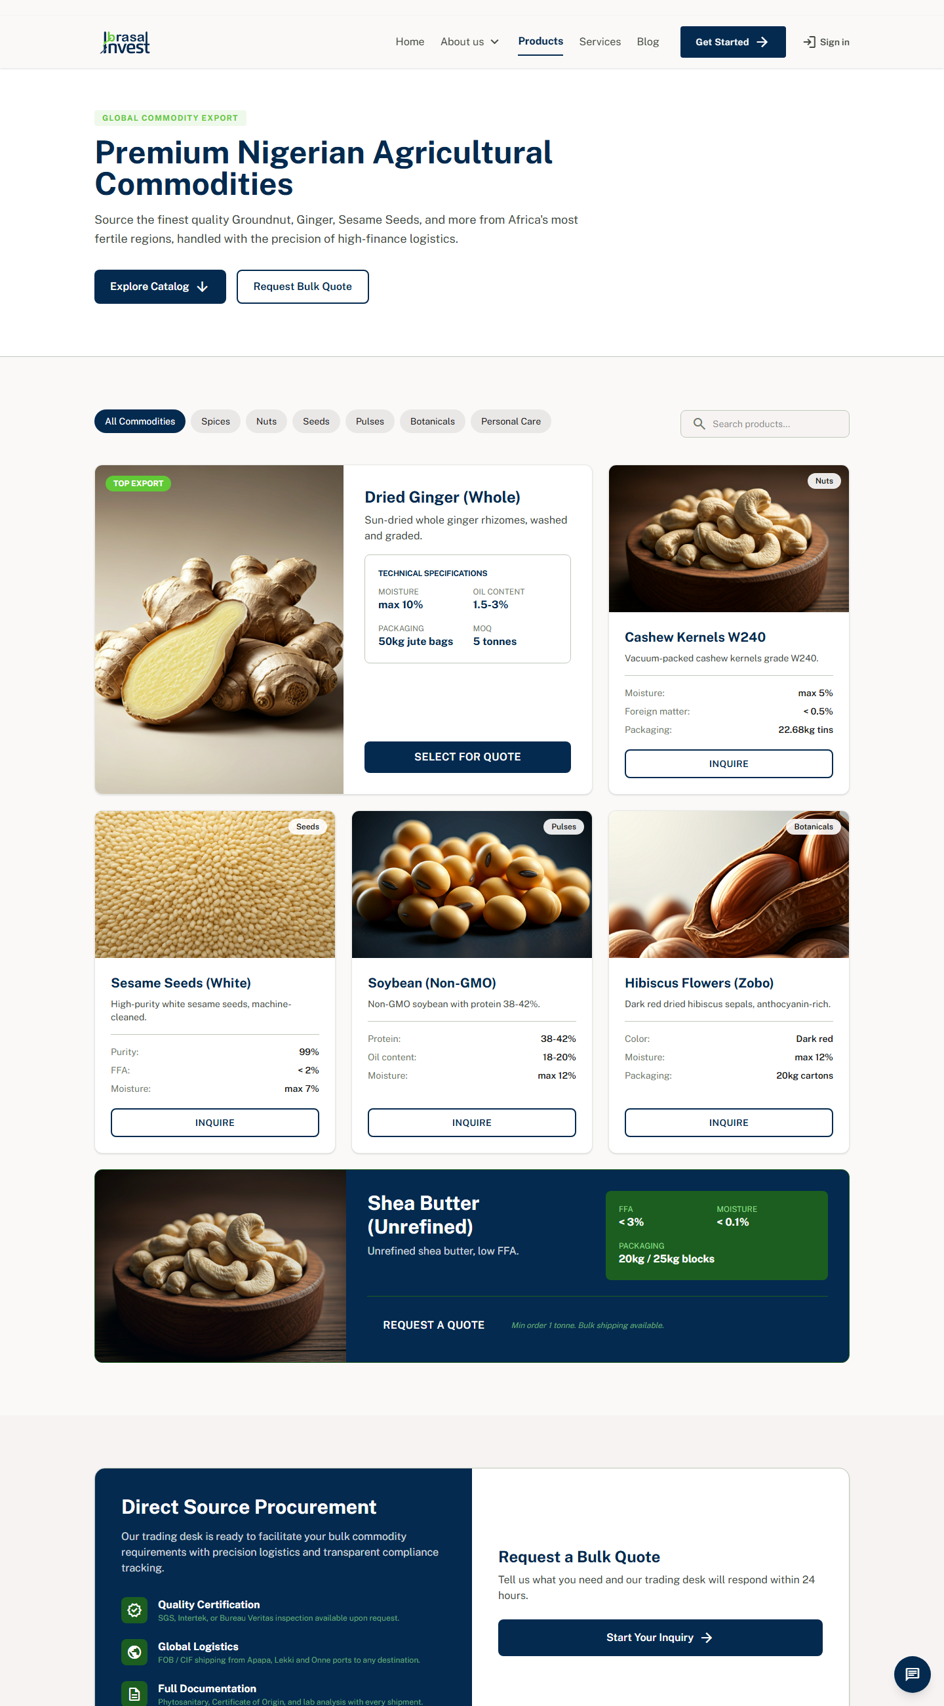
Marketplace — filterable bento catalogue of commodities

4.3 About, Our History & Our Team
The About section tells the company story across three builder-driven pages: About (mission, vision, core values, advantage, global reach), Our History (a milestone timeline, growth stats, operational gallery and roadmap) and Our Team (leadership cards pulled from the Team module, departments and culture gallery).
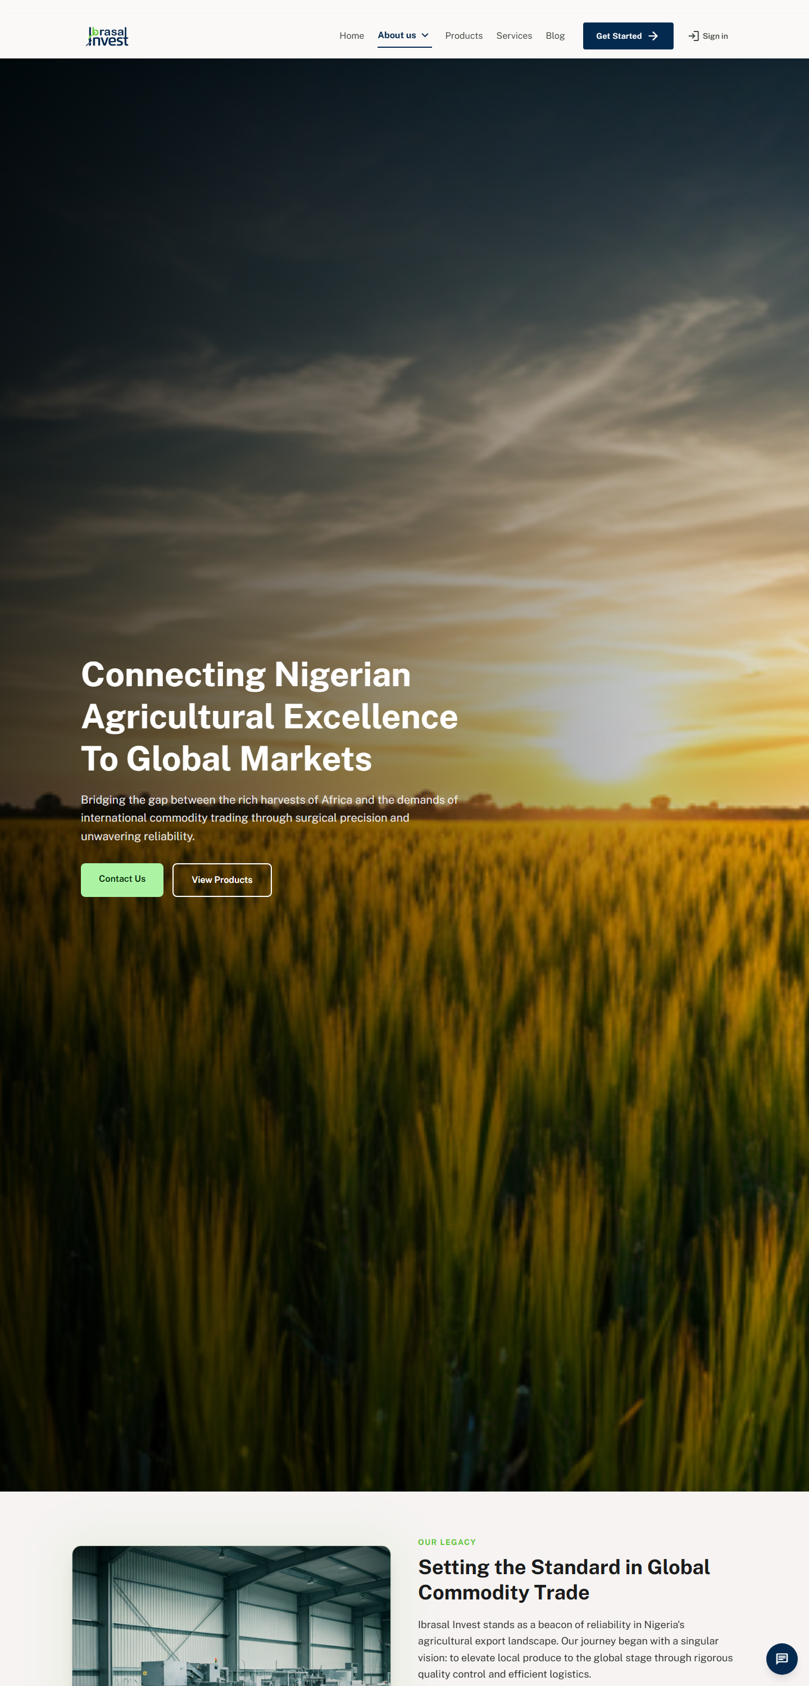
About Us — mission, values and the “Ibrasal Advantage”
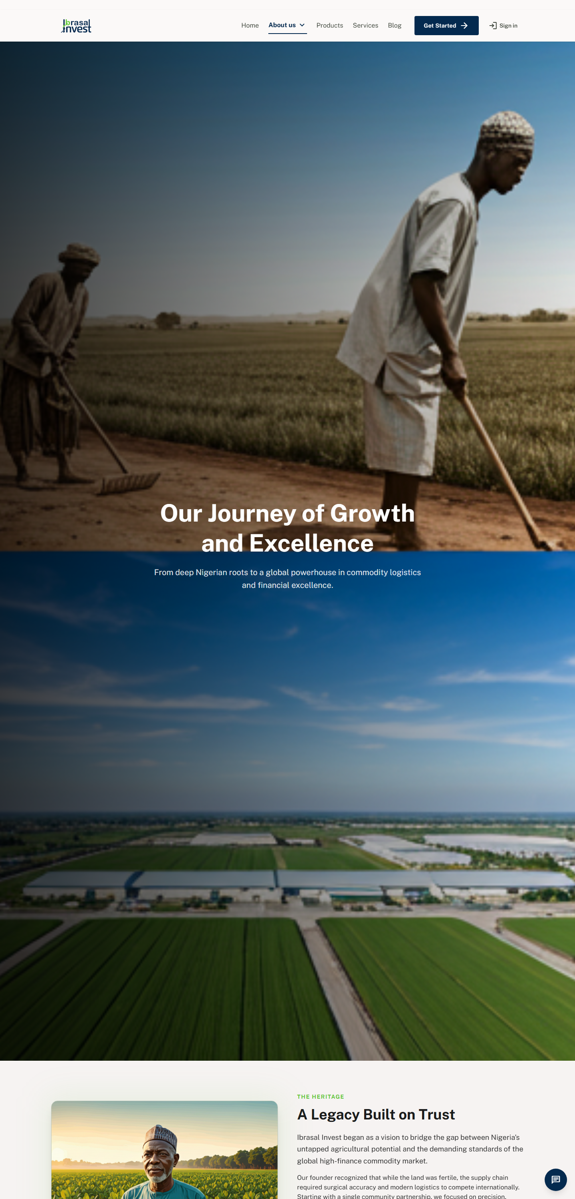
Our History — interactive milestone timeline & growth metrics

4.4 Blog
A market-intelligence blog with a featured post, category filters, a responsive grid, pagination and a newsletter signup. Each article has a styled single-post layout with related articles and share links.
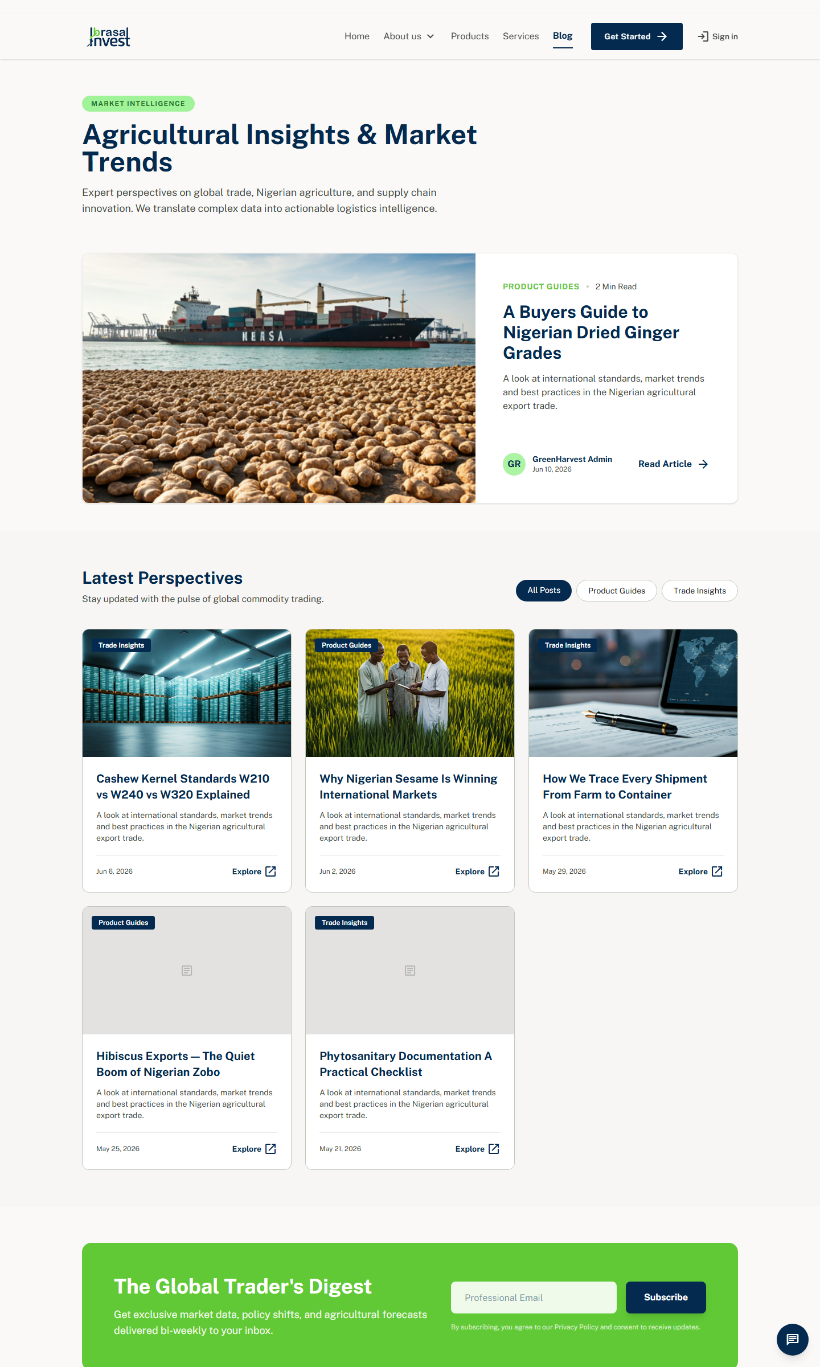
Blog index — featured post + latest perspectives

4.5 Contact
A functional contact page: an inquiry form (name, email, company, subject, message), office/HQ info cards, specialised department cards, a branded map and an FAQ accordion. Submissions create an admin notification.
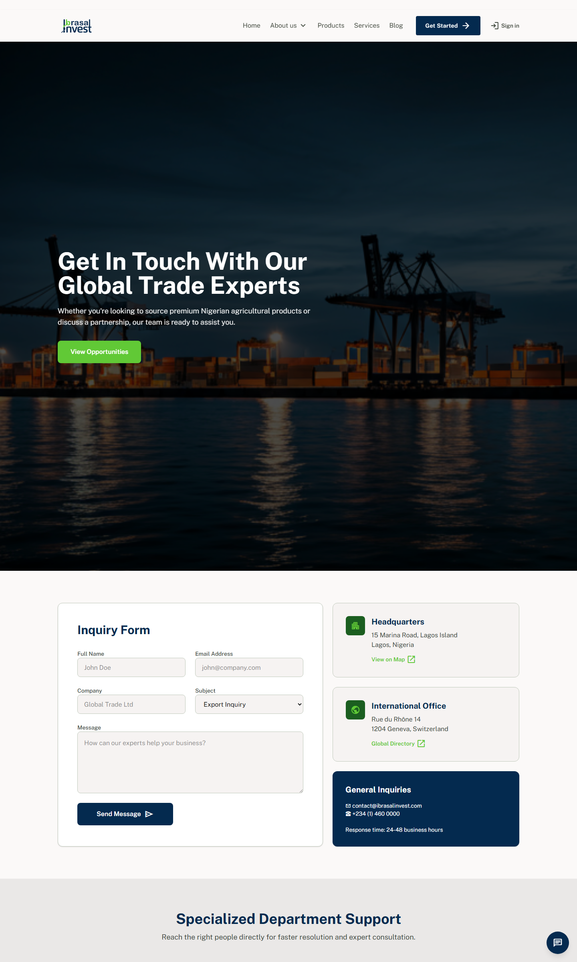
Contact — working inquiry form, info cards, map & FAQ

4.6 Legal Pages
Privacy Policy and Terms & Conditions use a professional legal-document layout: a sticky “Legal Center” side navigation, numbered sections, highlight cards and collapsible clauses — all editable from the page builder.
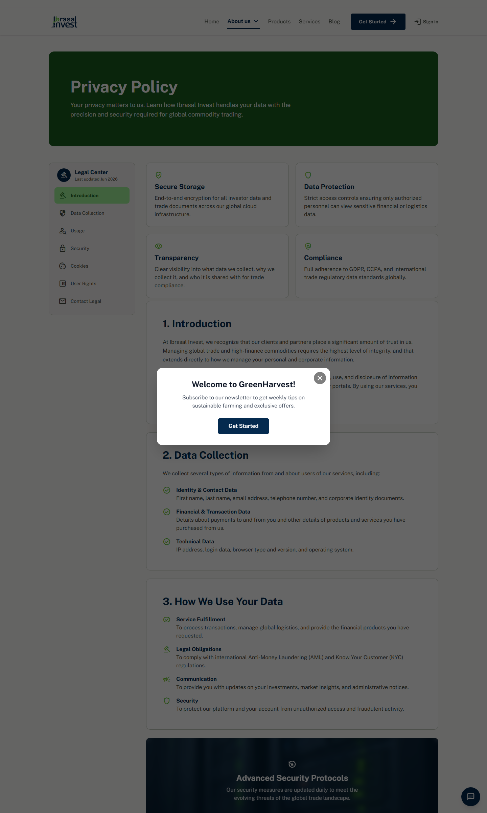
Privacy Policy — sticky side-nav legal layout

4.7 Get Started / Quote Request
A dedicated lead-capture form where buyers specify the product, quantity, unit, destination and timing. It feeds the same Inquiry pipeline used across the site.
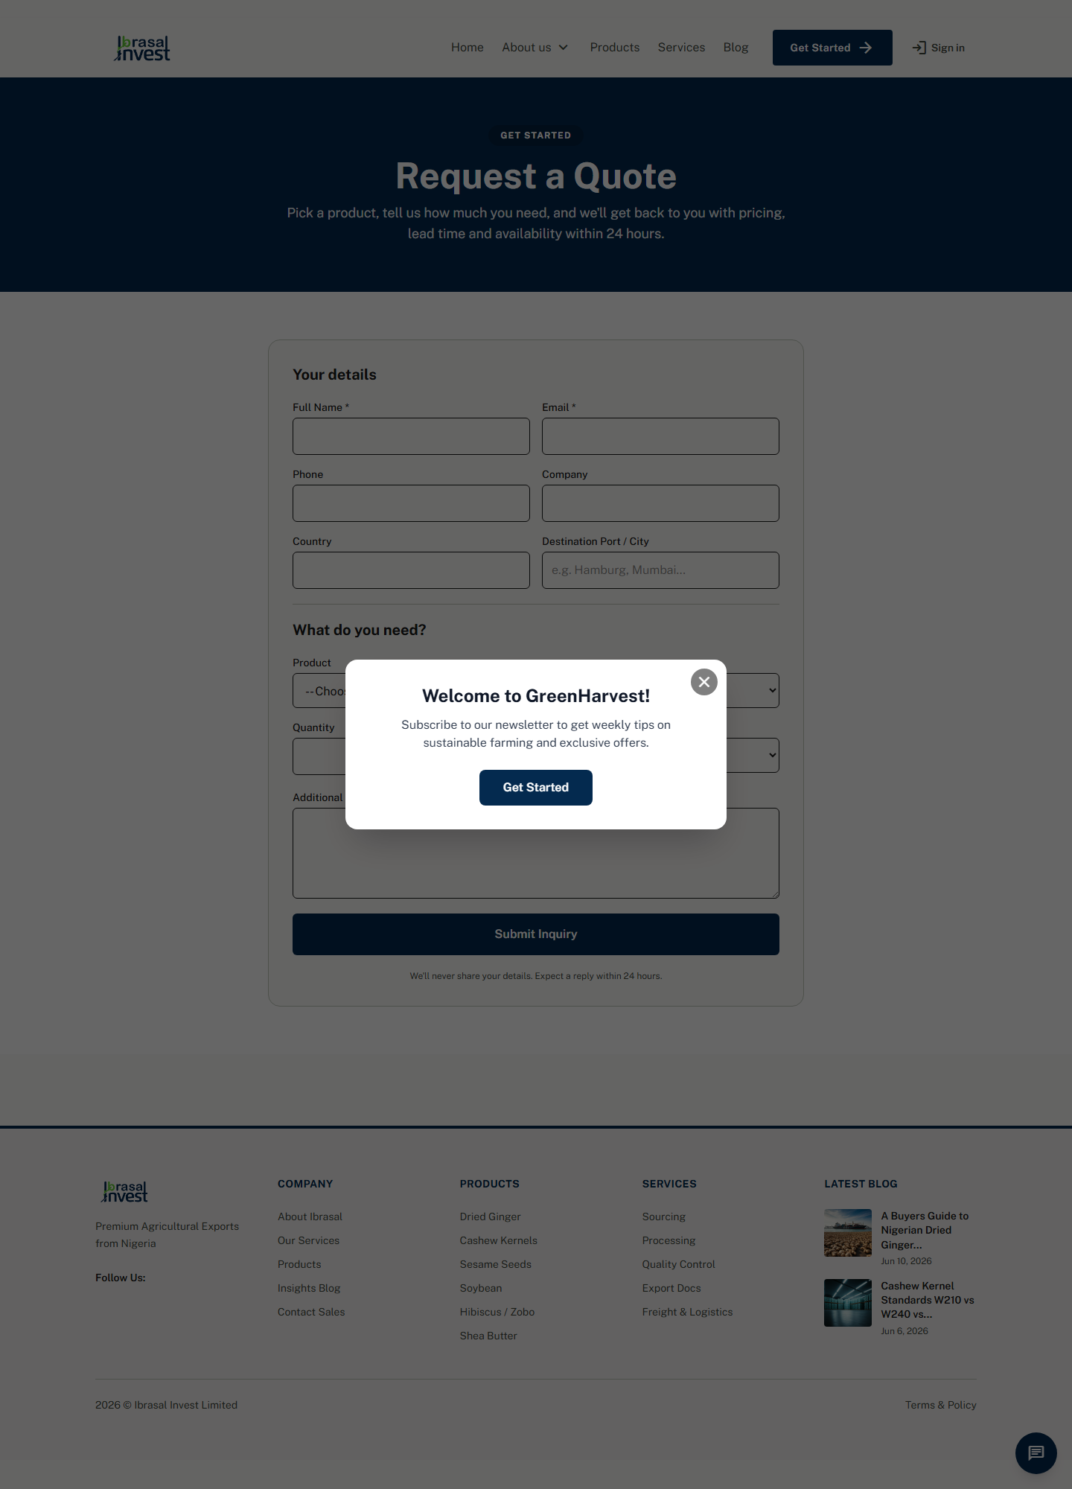
Get Started — central quote/inquiry capture form

5. Admin Panel & Portals
Three secure login areas serve three audiences:
- Admin — /login → full content + ERP back office (owner/manager).
- Staff — /login → operations portal (tasks, crops, livestock, inventory).
- Customer — /portal/login → buyer order tracking & receipts.
Login screens — Admin (left) and Customer Portal (right):
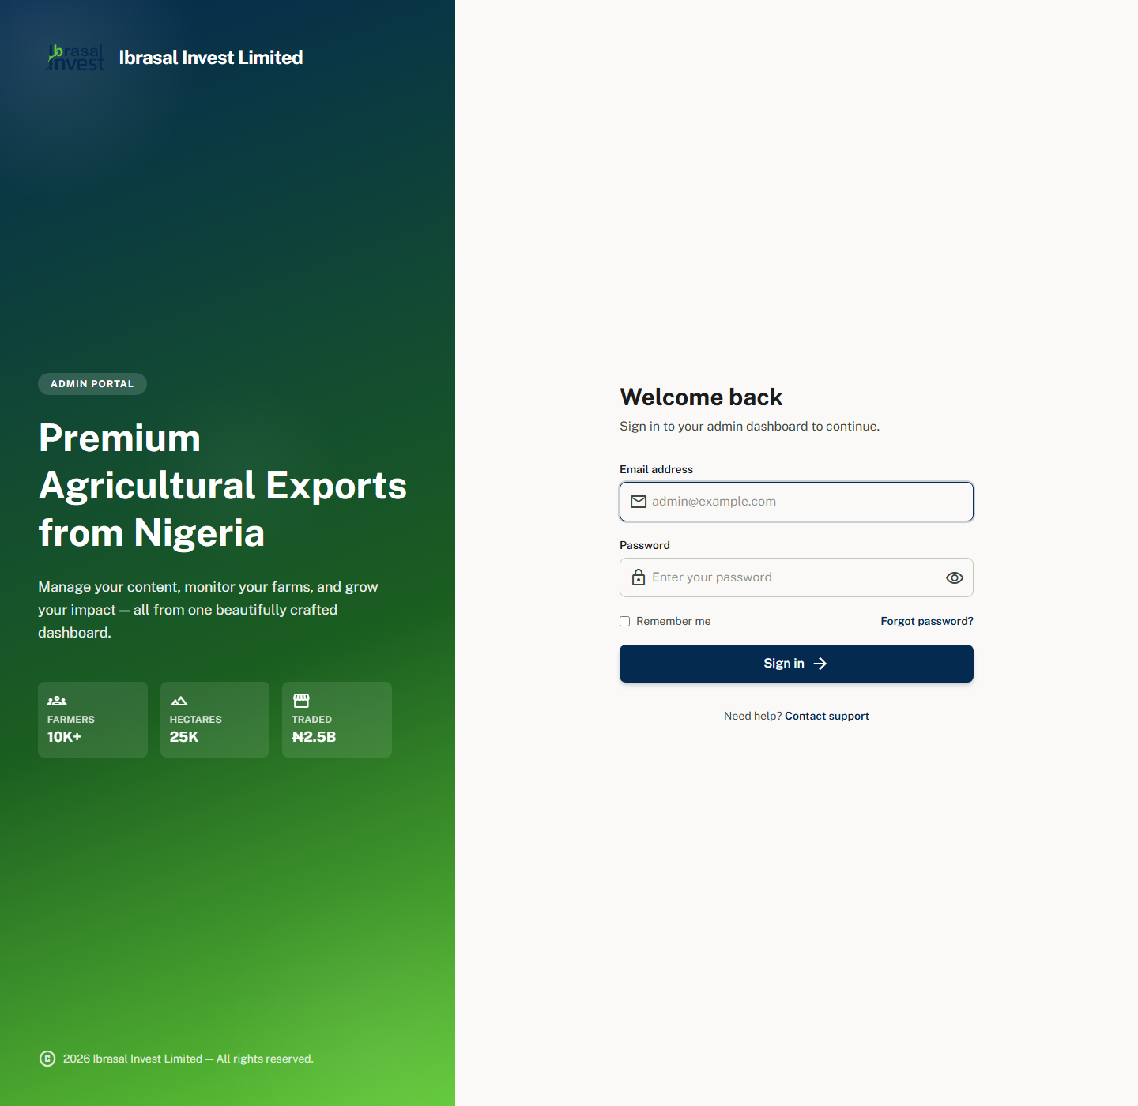 | 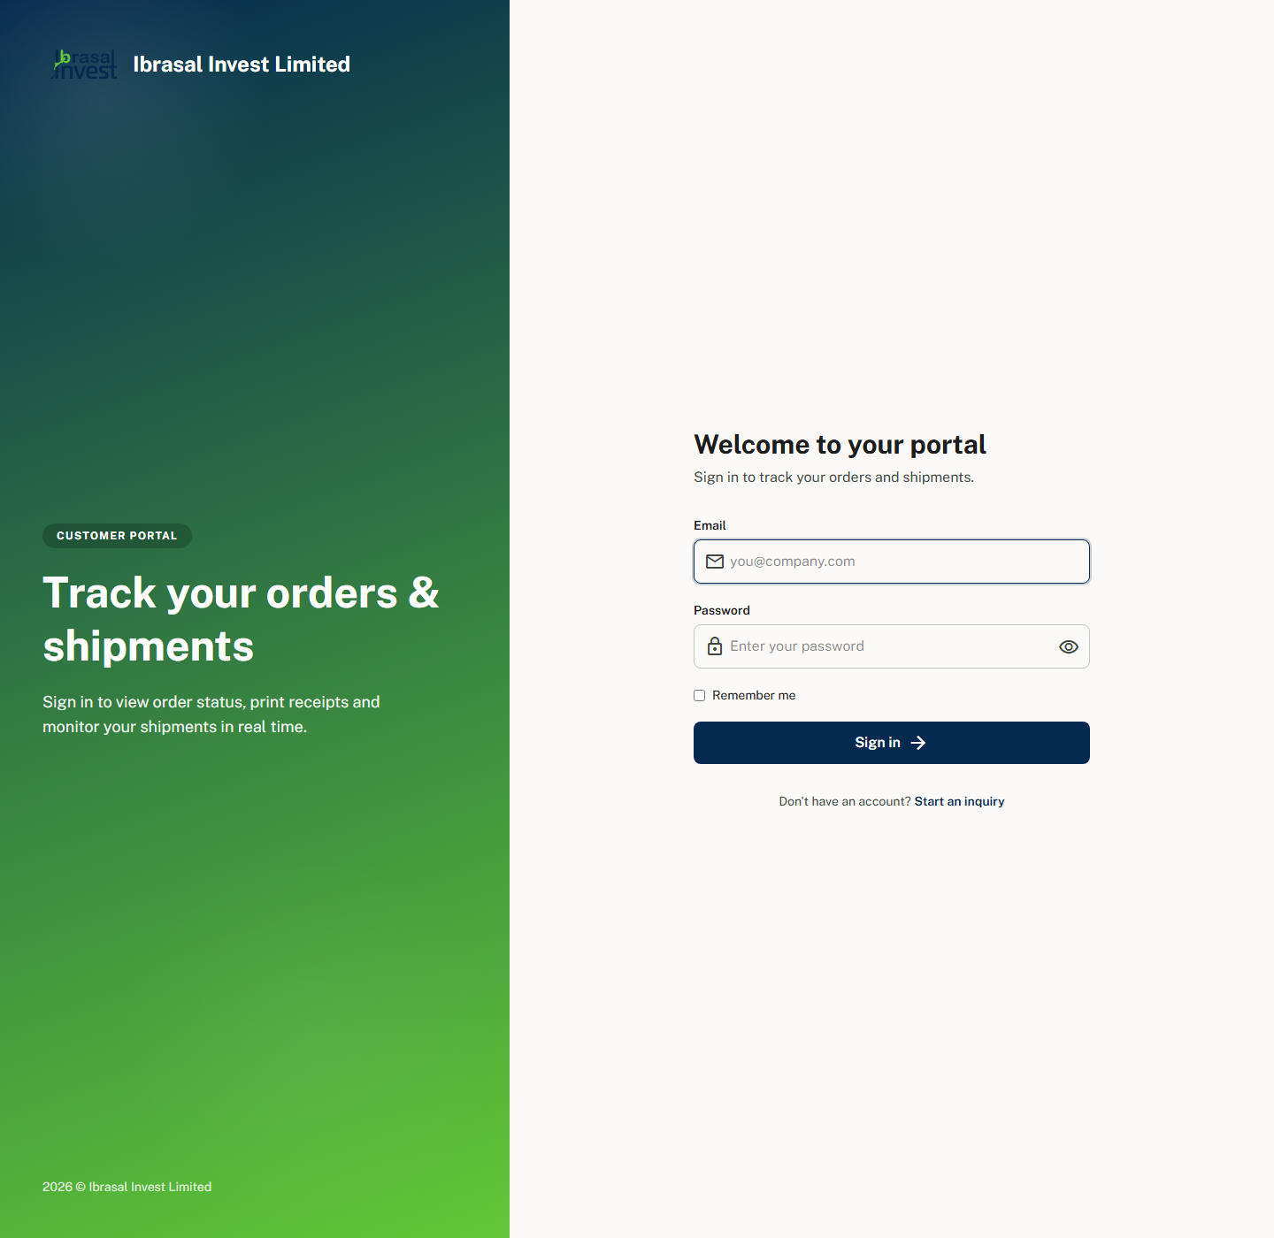

The Admin Dashboard
After logging in at /login, the admin lands on a dashboard with at-a-glance metrics — active products, shipments, unread live chats and net profit (income vs. expense, in Naira) — plus quick-jump cards, recent chats and the latest inquiry/chat notifications. A left sidebar groups every module into Content, Engagement, Media, Trade and System.
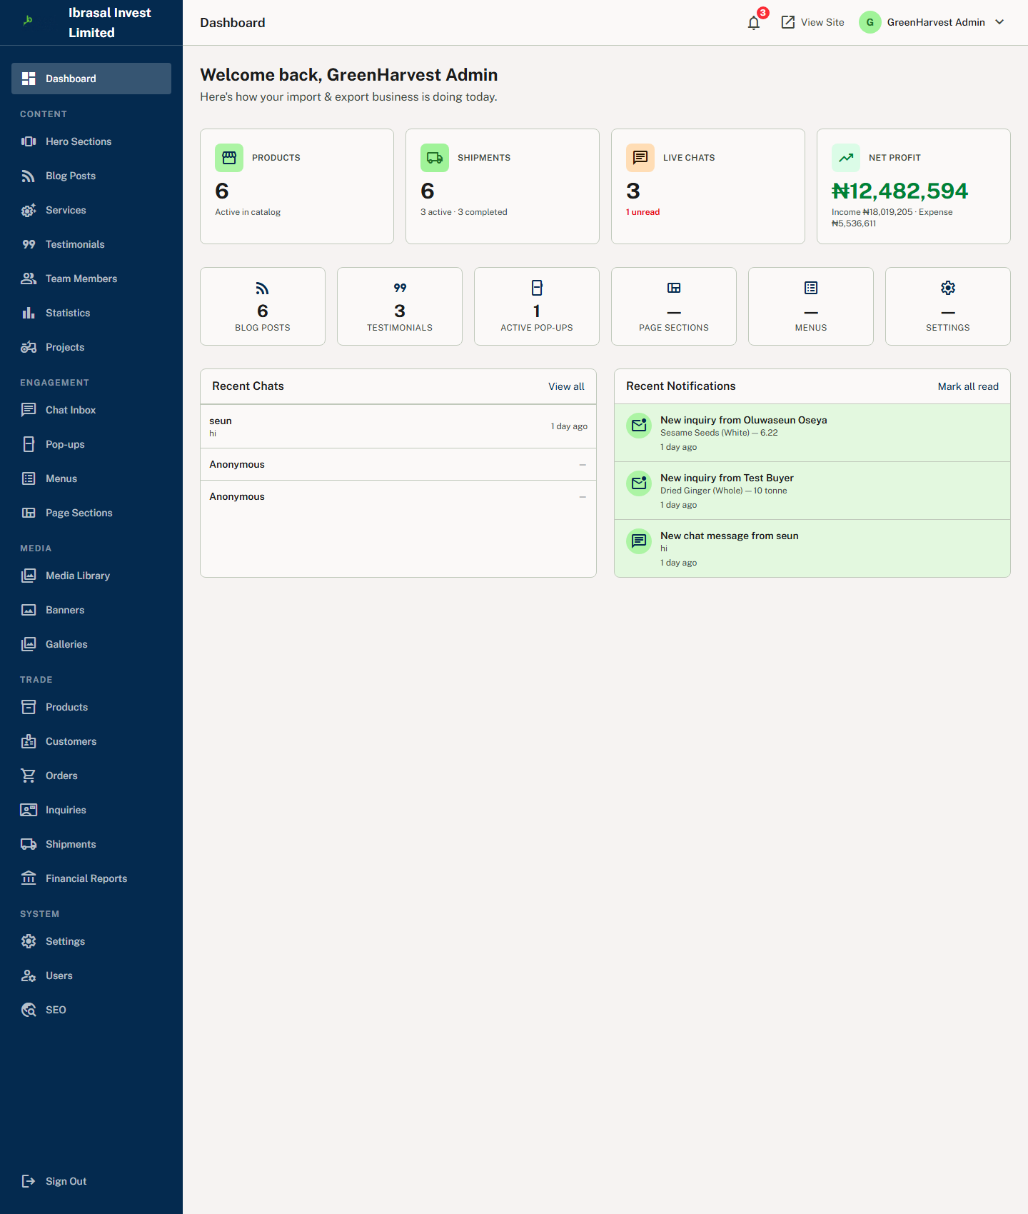
Admin Dashboard — KPIs, quick links, recent chats & notifications

Essential Admin Tabs Explained

Page Sections — the visual page builder
The most important tab for day-to-day editing. Pick any public page (Home, About, Our History, Our Team, Marketplace, Blog, Contact, Privacy, Terms) and edit it block-by-block: headings, body text, images (upload or URL), icons, background colours, buttons and card items. Sections can be added, reordered, toggled on/off and deleted — so the whole site is editable without touching code. A shortcut here links to the Hero slider manager.
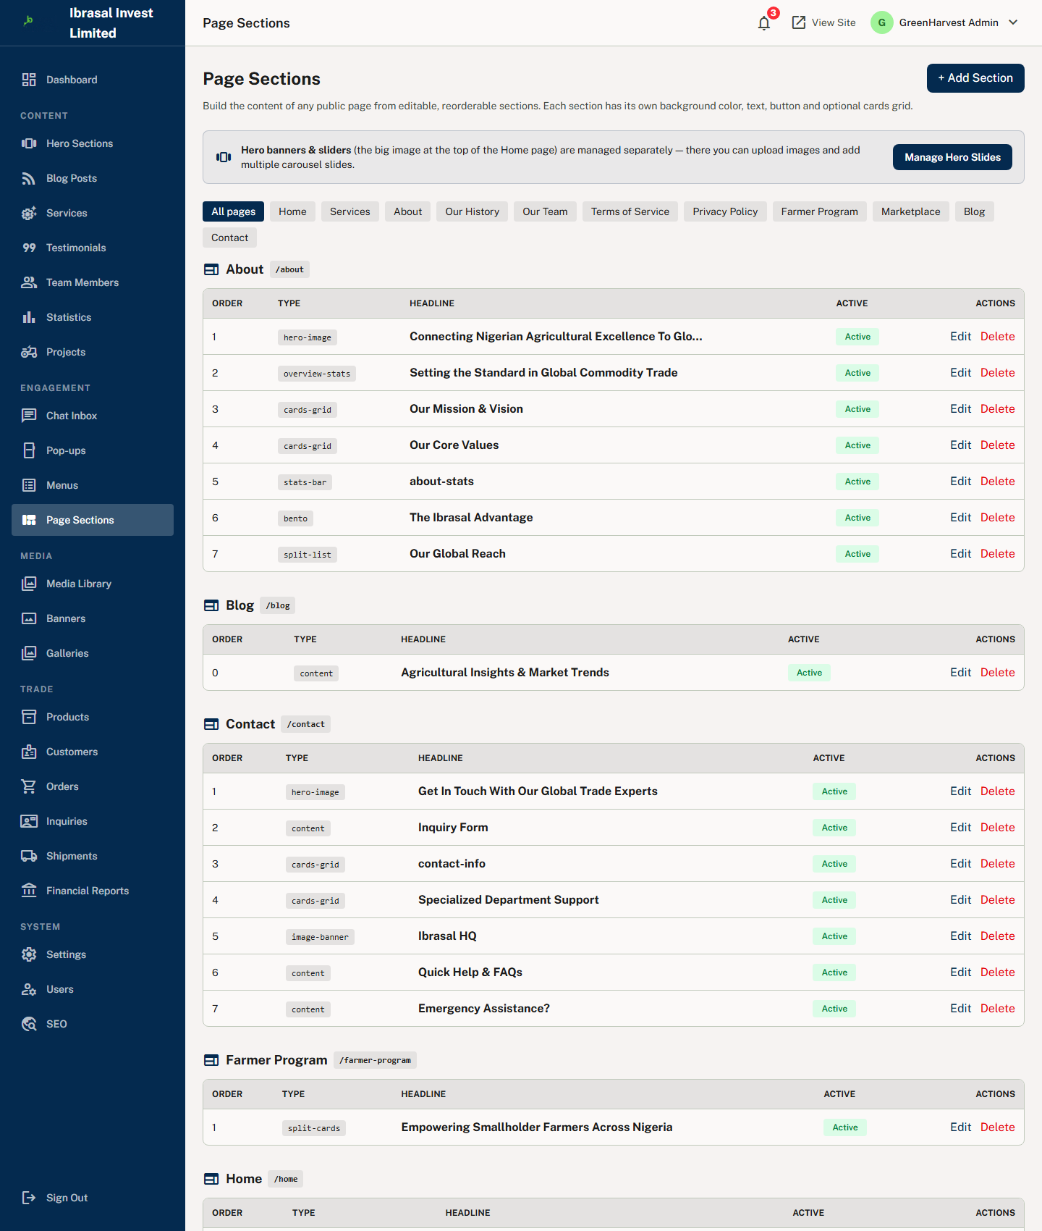
Page Sections — every block of every page is editable & reorderable

Hero Sections — banners & sliders
Manage the large hero banner at the top of the homepage (and other pages). Upload a background image, set the headline, subheading and two call-to-action buttons, and add multiple slides to create an auto-rotating carousel. This is where you change the main hero image.
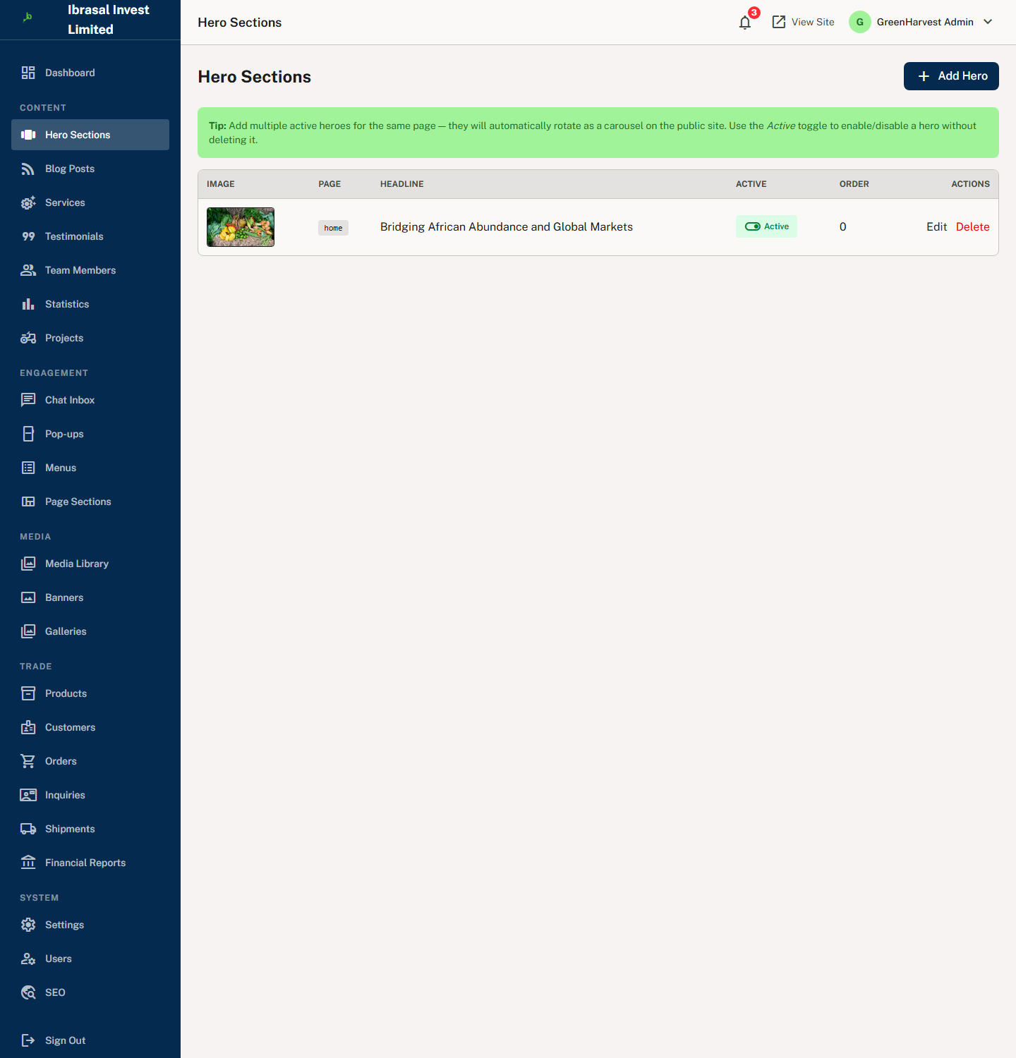
Hero Sections — image upload + multiple carousel slides

Products — your commodity catalogue
Create and manage every commodity: name, images, category, excerpt/description, grade, origin, technical specifications (oil content, moisture, purity, etc.), price-per-unit and currency, minimum order quantity, and the units buyers may choose (kg, tonne, bags, container). Products appear automatically on the homepage and marketplace, and drive the quote/order flow.
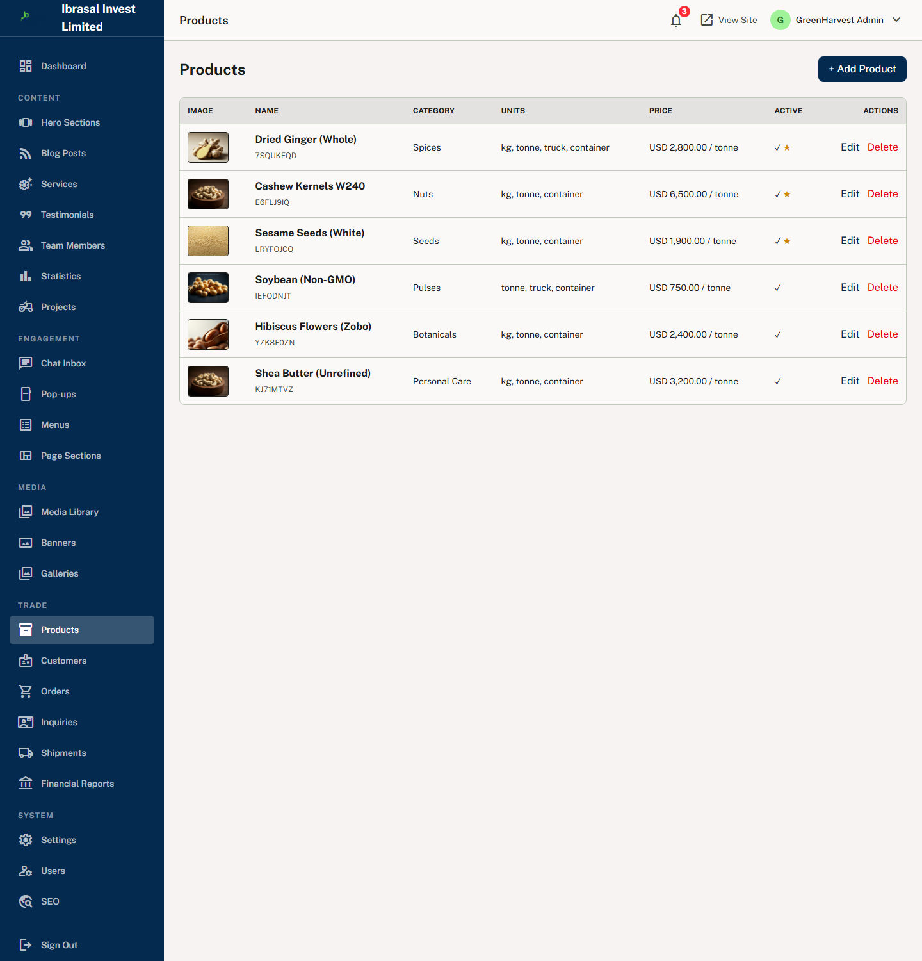
Products — catalogue with specs, units & pricing

Orders & Inquiries — the sales pipeline
Inquiries collects every quote request from product pages, the Get Started form and the contact page. The admin reviews each one and converts it into an Order. Orders manage the fulfilment lifecycle with status and shipment tracking entries that the customer sees in their portal.
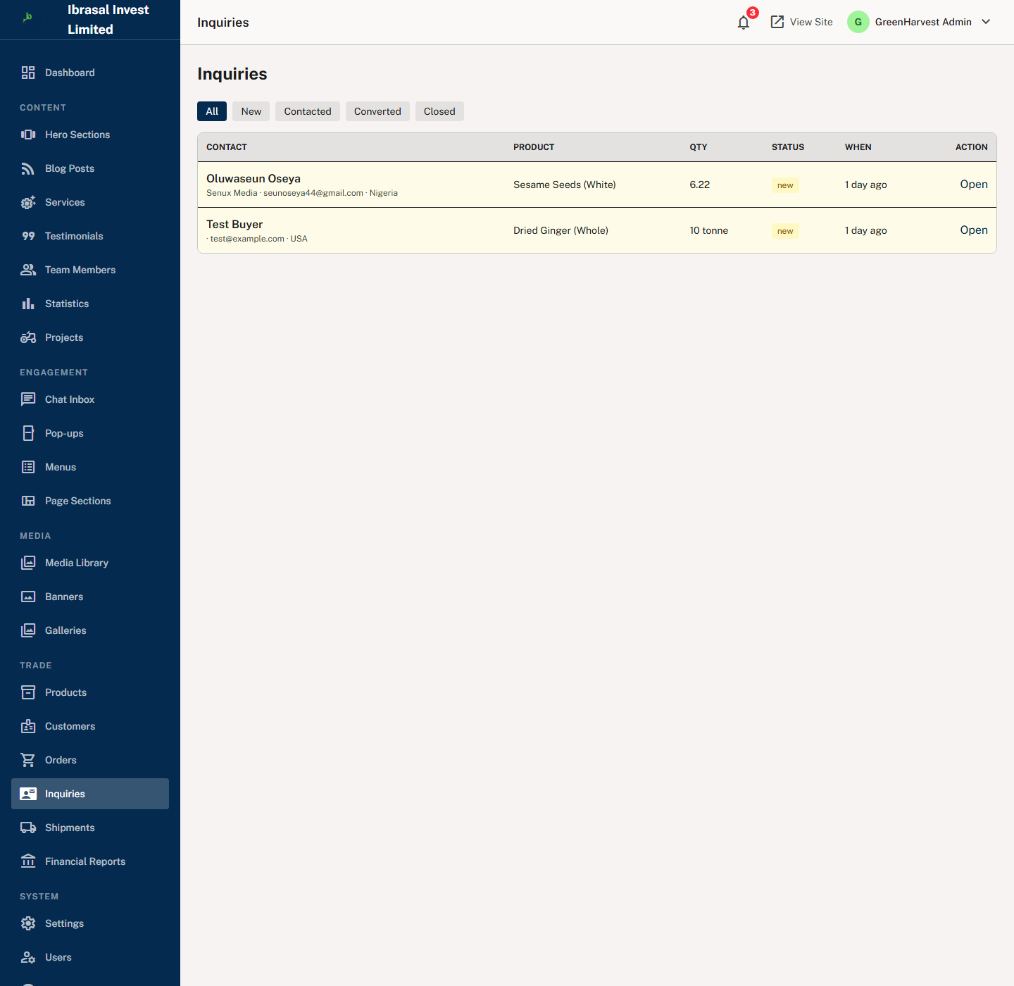  Inquiries inbox | 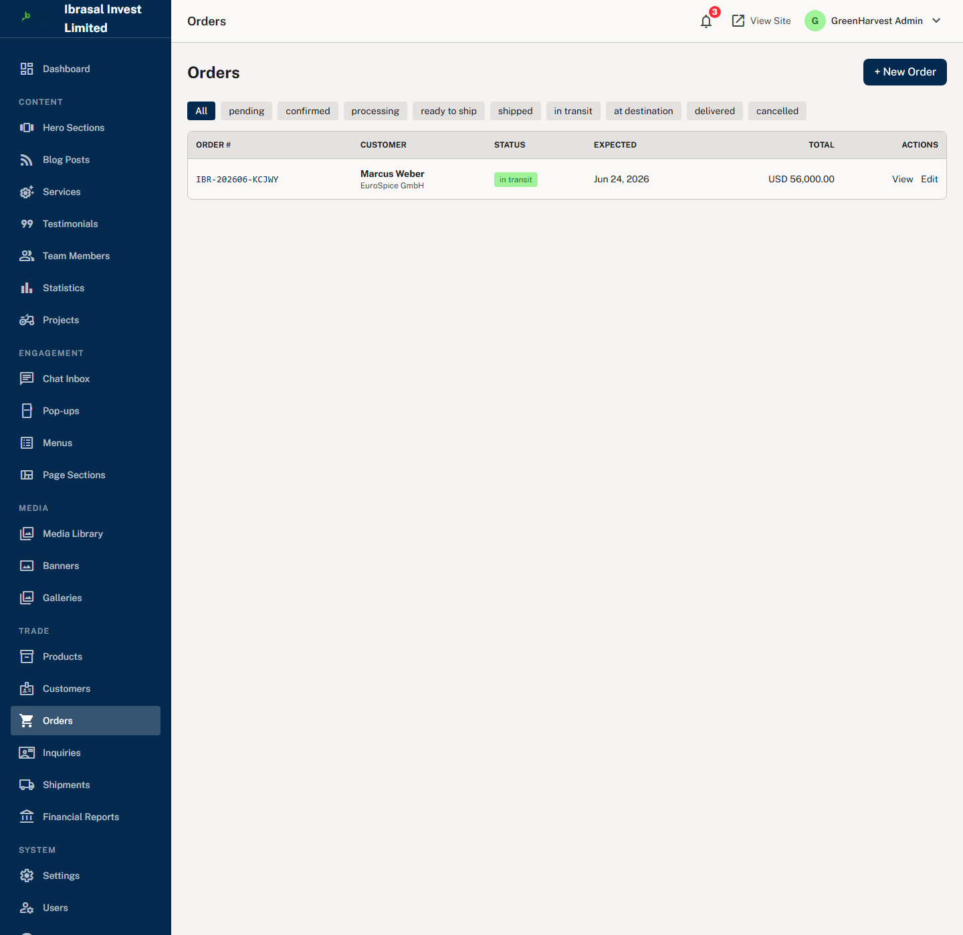  Orders & tracking

Blog — market insights
Write and publish articles with a featured image, category, tags, excerpt and body. Posts power the blog index, the single-post pages, the homepage Market Insights block and the newsletter audience.
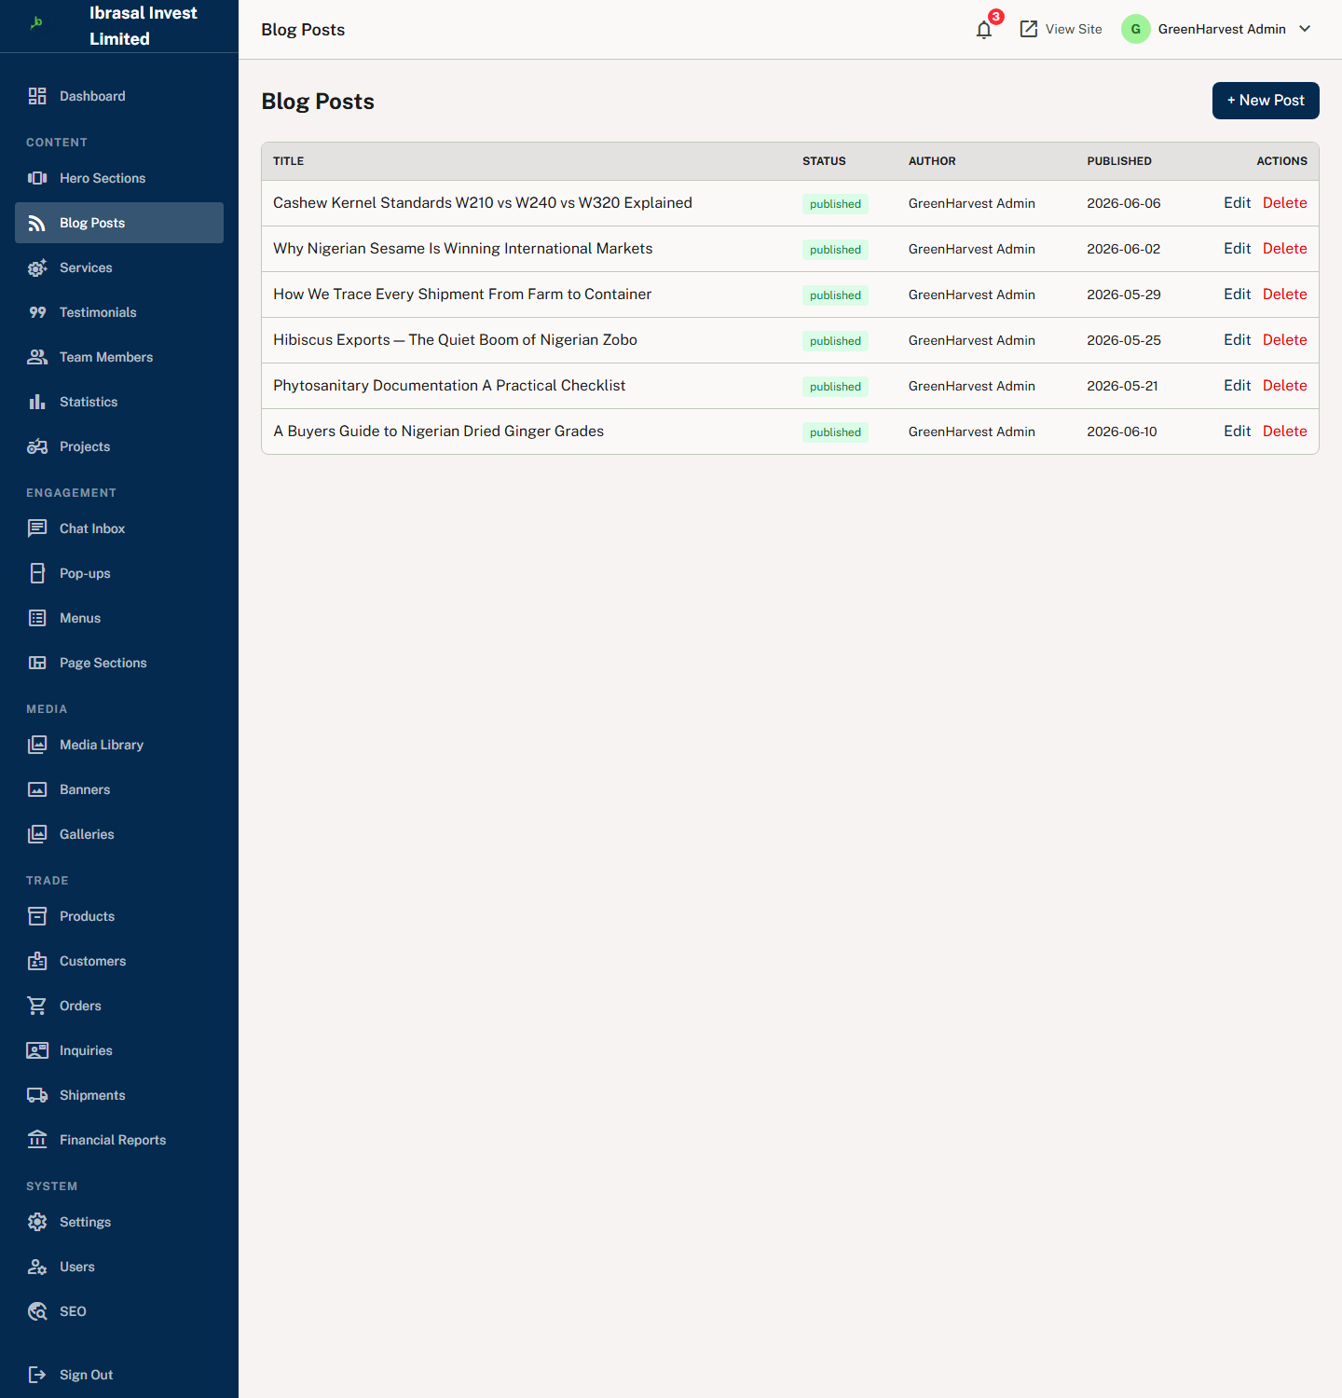
Blog manager — posts, categories & featured images

Settings — global branding
Control site-wide identity: company name, logo upload, brand colours, contact email/phone/address, social links and footer style. Changes apply across the public site, the login screens and the footer.
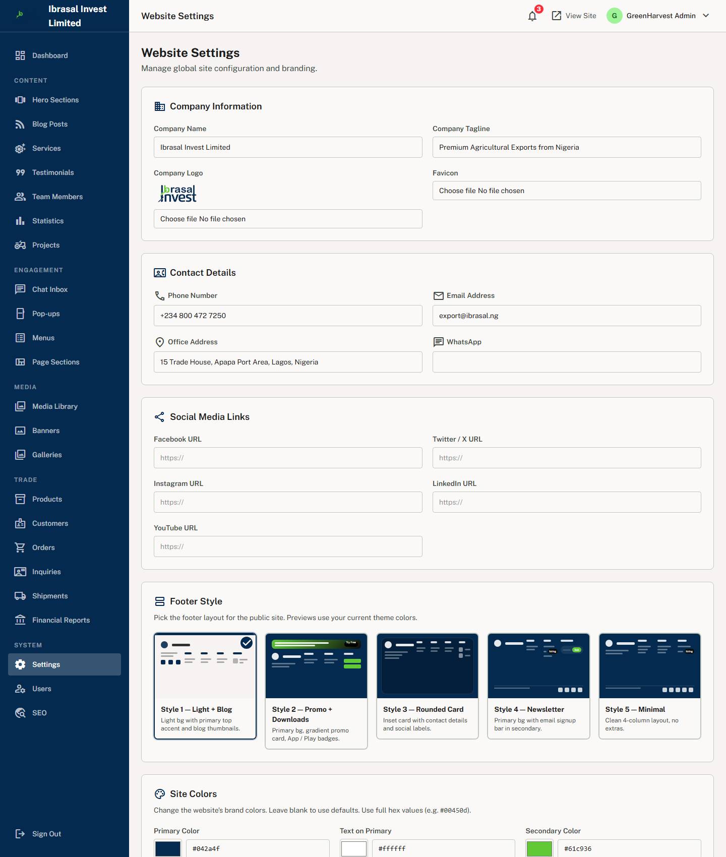
Settings — company branding, contact details & social links

Full Module List
Beyond the essentials above, the admin sidebar also includes:
- Content: Services, Testimonials, Team Members, Statistics, Projects.
- Engagement: Chat Inbox (live-visitor chat), Pop-ups, Menus.
- Media: Media Library, Banners, Galleries.
- Trade: Customers, Shipments, Financial Reports.
- System: Users (admin/staff accounts), SEO (per-page meta).
- Operations (staff/admin): Farms, Crops, Livestock, Inventory, Tasks, Finance.

6. Technology & Requirements
Item | Detail
Framework | Laravel 13 (PHP 8.3+)
Front end | Blade, Tailwind CSS 4, Alpine.js, Vite
Auth | Laravel Breeze (admin/staff) + custom customer portal auth
Database | SQLite out of the box; MySQL / PostgreSQL supported
Queue / Cache / Session | Database drivers (configurable)
Mail | Any SMTP provider (log driver by default)
Server | PHP 8.3+, Composer, Node.js 18+ for asset build

Quick Installation
- Unzip the package into your web root and run composer install.
- Copy .env.example to .env and run php artisan key:generate.
- Configure your database (SQLite works with zero config) and run php artisan migrate --seed.
- Run php artisan storage:link so uploaded images are served.
- Build assets with npm install && npm run build.
- Log in at /login with the seeded admin account and start editing from Admin → Page Sections.
Note (Windows): if image uploads do not display, recreate the storage link as a junction (mklink /J public\storage storage\app\public) or enable Developer Mode before running storage:link.

7. FAQs — Nigerian Market
Q: Is this built for the Nigerian agro-export market specifically?
A: Yes. The catalogue, copy, units (kg, tonne, bags, 20ft/40ft containers), ports (Apapa, Lekki, Onne) and document references (Phytosanitary, Certificate of Origin, NXP, EUR.1, SONCAP) are all geared toward Nigerian commodity export. It ships with sample commodities common to Nigeria: ginger, cashew, sesame, soybean, hibiscus (zobo) and shea.
Q: Can I price in Naira and/or USD?
A: Yes. Each product has its own currency and price-per-unit field, so you can quote in USD for export buyers or NGN for local trade. Prices are optional — many exporters prefer “Request a Quote”, which is fully supported.
Q: Do buyers pay online, or is it a quote/inquiry model?
A: Out of the box it uses a quote/inquiry model (no card payment) — which matches how most Nigerian bulk-commodity deals are negotiated (proforma invoice, LC, TT). A payment gateway (e.g. Paystack/Flutterwave) can be integrated on request.
Q: Will it work on slow connections / low-end devices common in Nigeria?
A: Yes. Assets are compiled and compressed (gzip), images are optimised, and the UI is lightweight (Tailwind + Alpine, no heavy framework). Pages render fast even on 3G.
Q: Can I run it on shared hosting (cPanel)?
A: Yes. It runs on standard PHP 8.3 shared hosting. SQLite needs no database server; for MySQL just point the .env to your cPanel database. Build the assets locally and upload the compiled files.
Q: How do I change the commodities, prices and specifications?
A: From Admin → Products. Add unlimited products with images, specs (oil content, moisture, purity, etc.), grade, origin, allowed units and minimum order quantity. They appear automatically on the homepage and marketplace.
Q: Can I edit every page myself without a developer?
A: Yes — that is the core design. Admin → Page Sections lets you edit text, images, stats, cards, icons, colours and buttons on every page, and reorder or hide sections. Hero banners are managed in the Hero area with image upload and multiple slides.
Q: Does it support multiple languages?
A: Yes — English and French are included with a one-click locale switch, and a fallback locale. Additional languages can be added via Laravel’s standard translation files.
Q: How are buyer inquiries handled?
A: Every product inquiry and contact submission creates an in-app admin notification (and an email if SMTP is set). Admins review inquiries, respond, and convert them into tracked orders that customers follow in their portal.
Q: Is it SEO-ready for Google?
A: Yes. Each page has editable SEO meta (title, description), clean slugs, semantic headings and fast load times. A blog is included to publish market insights and rank for commodity keywords.
Q: Can I use my own branding (logo, colours, company name)?
A: Yes. Admin → Settings controls the company name, logo upload, brand colours, contact details and social links across the whole site, including the login and footer.
Q: Is the source code clean and reusable for other clients?
A: Yes. It is a standard, conventional Laravel codebase (controllers, Eloquent models, Blade views, migrations, seeders) — easy to rebrand, extend and resell.

8. Support & Credits
This documentation accompanies the Ibrasal Invest platform, designed and developed by SENUX Media.
For customisation, integrations (payment gateways, additional languages, custom commodities, ERP extensions) or any enquiry, contact SENUX support: business@senux.xyz
Built by SENUX Media
Customisation & enquiries · business@senux.xyz
Thank you for choosing Ibrasal Invest.

Built by SENUX Media. For customization and enquiries, contact SENUX support: business@senux.xyz

