SK-XPRESS
L O G I S T I C S
The Complete Delivery & Courier Management Platform
Fast. Reliable. Delivered.
Product Guide & Buyer Overview
Web App • Mobile App • Admin Dashboard
Designed & developed by SENUX Media
business@senux.xyz

Table of Contents

SK-Xpress Logistics — Delivery & Courier Management Platform
SK-Xpress Logistics is a complete, ready-to-launch software platform for running a modern delivery, dispatch, or courier business. It brings together everything an operator needs — a customer website, mobile apps for customers and riders, and a powerful back-office admin dashboard — into one connected system.
Built specifically for the realities of the African market and Nigeria in particular, it handles the entire journey of a parcel: a customer books a delivery, the system instantly calculates the price and finds the nearest available rider, the customer tracks the rider live on a map, the receiver confirms delivery with a secure code sent by WhatsApp, and the rider is paid their commission automatically.
Instead of spending months and a large budget building a delivery platform from scratch, a business can deploy SK-Xpress and start taking orders almost immediately — fully branded, payment-ready, and built to scale.

What Is This Software?
In simple terms, SK-Xpress Logistics is the “engine room” of a delivery company. It is the software that receives orders, organises riders, collects payments, keeps customers informed, and gives the business owner complete visibility and control.
Think of the popular ride-hailing and parcel-delivery apps you already know — SK-Xpress gives you that same experience, but as a product you own and control, tailored to courier and dispatch operations.

Three connected parts, one system
Component | What it is
Customer Web App | A clean, branded website where customers register, book deliveries, pay, track parcels, and manage a wallet — on any phone or computer.
Mobile Apps | Native apps for Android and iOS — one experience for customers booking parcels, and a dedicated dashboard for riders on the road.
Admin Dashboard | A professional control centre where the business manages users, riders, deliveries, payments, pricing and reports.

Who Is It For?
SK-Xpress is designed for anyone who moves parcels or wants to start a delivery business:
- Dispatch & courier companies that want to digitise phone-and-paper operations into a professional, trackable system.
- E-commerce & social-commerce sellers (Instagram, WhatsApp and online stores) that need reliable, in-house delivery and tracking.
- Entrepreneurs & startups who want to launch their own “Uber for parcels” brand without building software from zero.
- Local businesses (restaurants, pharmacies, supermarkets) offering same-day delivery to customers.
- Organisations & institutions that manage internal logistics and need accountability and reporting.
- Agencies and developers who want a proven, white-label platform to deploy for their own clients.

Why Do People Need This Software?
Most delivery operations still run on phone calls, WhatsApp messages, paper waybills, and manual rider coordination. This causes daily problems — lost parcels, “where is my delivery?” calls, payment disputes, and no clear picture of the business. SK-Xpress solves these directly:
The problem | How SK-Xpress solves it
Customers keep calling to ask where their parcel is | Live map tracking and automatic WhatsApp updates at every stage
Parcels delivered to the wrong person | A secret one-time code (OTP) the receiver must give the rider to confirm delivery
Slow, manual rider dispatch | The system automatically assigns the nearest available rider in seconds
Cash handling, theft and payment disputes | Secure card payments and prepaid wallets — money goes straight to the business
Arguments over rider pay | Automatic, transparent commission recorded on every delivery
No visibility of the business | A live dashboard showing orders, riders, revenue and performance

Business Benefits
Save time through automation
- What it does: Pricing, rider assignment, customer notifications and payment confirmation all happen automatically.
- Why it matters: Staff no longer spend hours on the phone coordinating each delivery.
- Benefit: One person can manage what used to need a whole dispatch team.
Reduce costs
- What it does: Replaces manual coordination, paper records, and expensive custom software development.
- Why it matters: Runs on affordable shared hosting — no costly servers required.
- Benefit: Lower running costs and a far cheaper start than building from scratch.
Increase revenue
- What it does: Built-in card payments, customer wallets, and a configurable pricing engine.
- Why it matters: Every delivery is priced consistently and paid for upfront.
- Benefit: More completed orders, faster payment, and new income streams.
Delight customers
- What it does: Live tracking, instant updates, and a polished, branded experience.
- Why it matters: Customers trust a business that keeps them informed.
- Benefit: More repeat orders, referrals, and a premium brand image.
Stay in control
- What it does: A real-time dashboard and complete records of every delivery, rider and payment.
- Why it matters: Owners can see exactly what is happening at any moment.
- Benefit: Better decisions, full accountability, and no blind spots.

Key Features

For customers
Easy parcel booking
- What it does: A guided step-by-step form to book a delivery: choose the service, enter pickup and drop-off, and add parcel details.
- Why it matters: Customers can book correctly in under a minute with no confusion.
- Benefit: Fewer mistakes, more completed bookings.
Instant, transparent pricing
- What it does: The price is calculated automatically from distance, weight and service type, and shown before the customer commits.
- Why it matters: No haggling and no surprises.
- Benefit: Customers trust the price and book with confidence.
Live tracking
- What it does: Customers watch the rider move on a map and see the delivery status update in real time.
- Why it matters: It removes the anxiety of “where is my parcel?”.
- Benefit: Happier customers and fewer support calls.
Secure delivery confirmation
- What it does: The receiver gets a one-time code by WhatsApp that the rider must enter to complete the delivery.
- Why it matters: It guarantees the parcel reached the right person.
- Benefit: Eliminates “I never received it” disputes.
Wallet & card payments
- What it does: Customers can pay per delivery or top up a wallet using cards, bank transfer or USSD.
- Why it matters: Familiar, trusted local payment options.
- Benefit: Faster checkout and reliable payment collection.
Address book & history
- What it does: Saved addresses and a full record of past and active deliveries.
- Why it matters: Frequent senders re-book in seconds.
- Benefit: Convenience that keeps customers coming back.

For riders (staff)
Automatic job assignment
- What it does: The nearest available rider is offered each new delivery automatically.
- Why it matters: No dispatcher is needed and pickups are faster.
- Benefit: A leaner operation and quicker service.
Simple status updates
- What it does: Riders move a delivery through clear stages — accepted, picked up, in transit, arrived, delivered.
- Why it matters: Customers are always informed and riders know exactly what to do.
- Benefit: Smooth deliveries and transparent progress.
Transparent earnings
- What it does: Each completed delivery automatically credits the rider their commission, with a running total.
- Why it matters: Riders see exactly what they have earned.
- Benefit: Motivated riders and no payment arguments.

For the business (admin)
Complete delivery oversight
- What it does: Every delivery is visible with its route, rider, price and status; admins can re-assign riders when needed.
- Why it matters: Nothing falls through the cracks.
- Benefit: Total operational control.
Rider management & approval
- What it does: Review, approve, suspend and monitor riders from one screen.
- Why it matters: Keeps the fleet trusted and high quality.
- Benefit: A reliable, accountable delivery team.
Live business dashboard
- What it does: At-a-glance numbers: users, active riders, deliveries today, and monthly performance.
- Why it matters: The owner always knows how the business is doing.
- Benefit: Confident, data-driven decisions.
Feature switches & pricing control
- What it does: Turn features on or off and adjust pricing without any technical help.
- Why it matters: The business adapts instantly to its needs.
- Benefit: Flexibility without paying a developer.
Roles & permissions
- What it does: Create staff roles with exactly the access each person should have.
- Why it matters: Sensitive areas stay protected.
- Benefit: Safe delegation as the team grows.

How The System Works
From order to delivery, the whole process is simple and automatic:
- A customer registers and books a delivery, entering pickup, drop-off and parcel details.
- The system instantly calculates the price and the customer pays by card or wallet.
- The nearest available rider is automatically assigned and accepts the job.
- The customer tracks the rider live as the parcel is picked up and moved.
- The receiver gets a secure one-time code by WhatsApp.
- On arrival, the receiver gives the code to the rider to confirm delivery.
- The delivery is marked complete and the rider’s commission is paid automatically.
- Every step is recorded, and the admin sees it all live on the dashboard.

User Roles
SK-Xpress has three clear roles, each with its own experience:
Role | What they can do
Administrator | The business owner or manager. Full access to the admin dashboard — users, riders, deliveries, payments, pricing, settings and reports.
Customer | The person sending a parcel. Books deliveries, pays, tracks orders, manages a wallet and saved addresses.
Rider (Staff) | The delivery person. Goes online, receives and accepts jobs, updates delivery status, confirms with the code, and tracks earnings.

Admin Dashboard Overview
The admin dashboard is the control centre of the business — a clean, professional back-office that requires no technical skill to use.

Business Dashboard
The home screen shows the numbers that matter most at a glance: total customers, riders currently online, deliveries booked today, and deliveries completed this month.
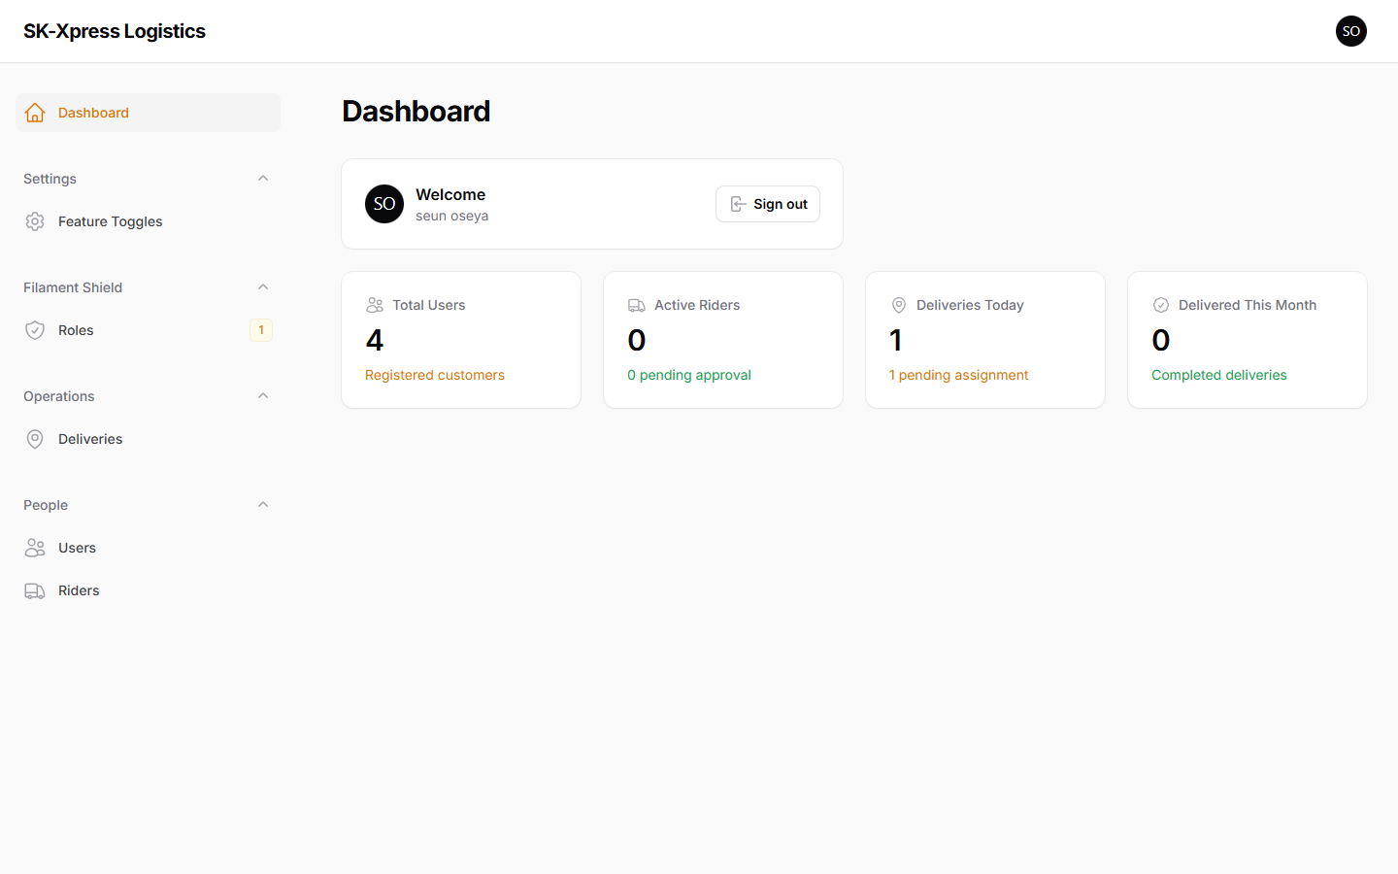
The admin dashboard — live business statistics at a glance.

User Management
A complete, searchable list of every customer and staff member. Admins can view details, manage accounts, and assign roles.
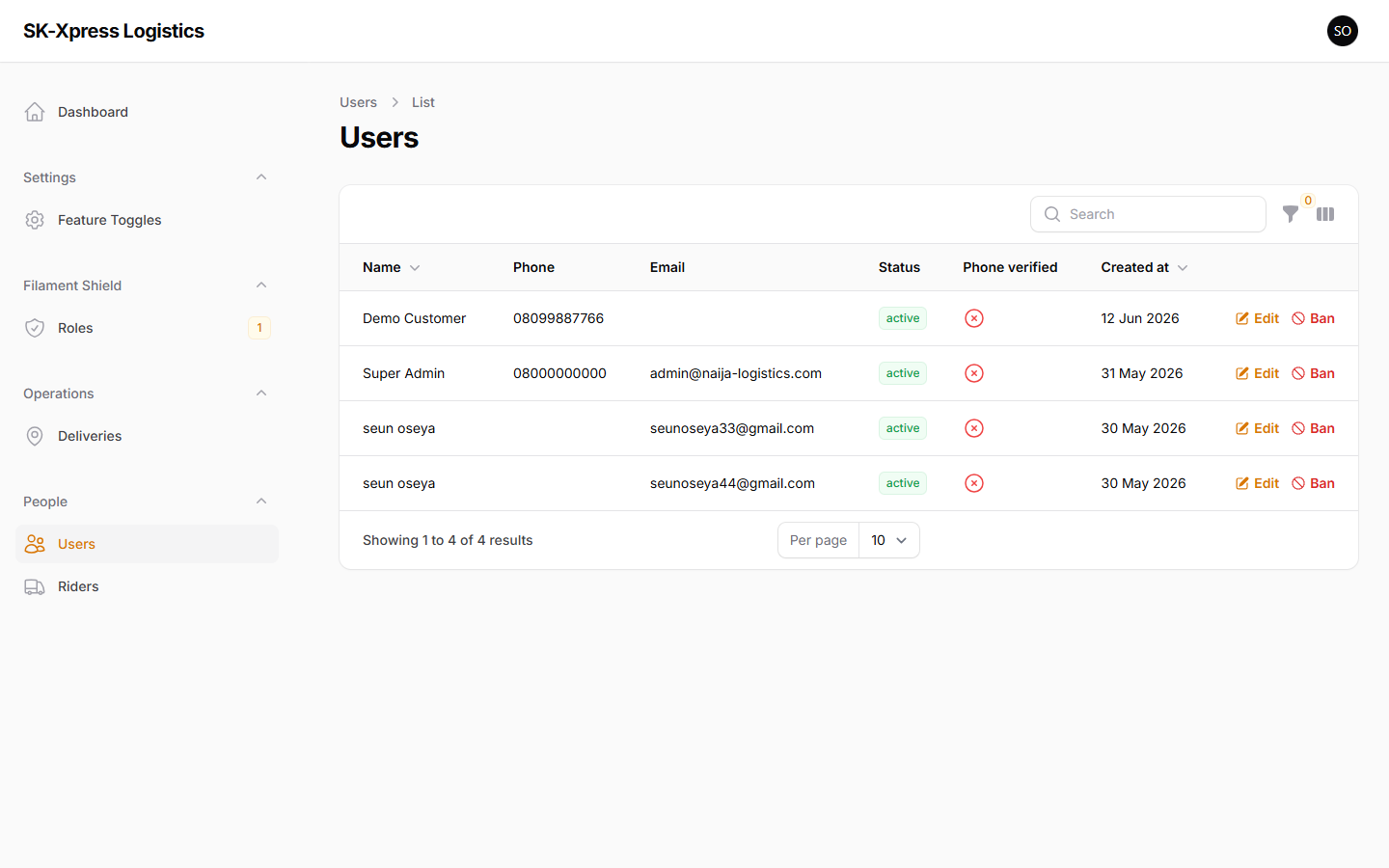
User management — every customer and staff account in one place.

Rider Management
Approve new rider applications, see who is online, and manage the delivery fleet — all from a single screen.
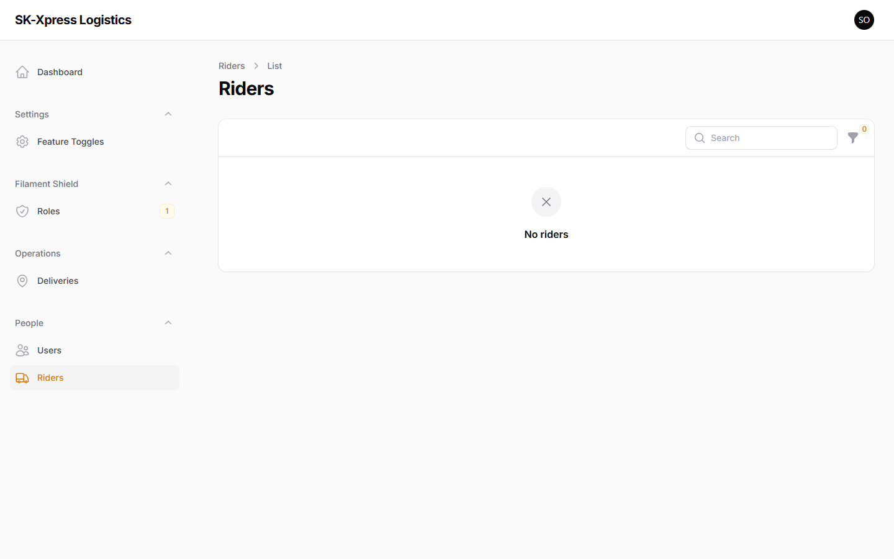
Rider management — approve and oversee the delivery fleet.

Delivery Management
Every delivery on the platform with its reference, route, price and status. Admins can assign or re-assign riders and resolve issues instantly.
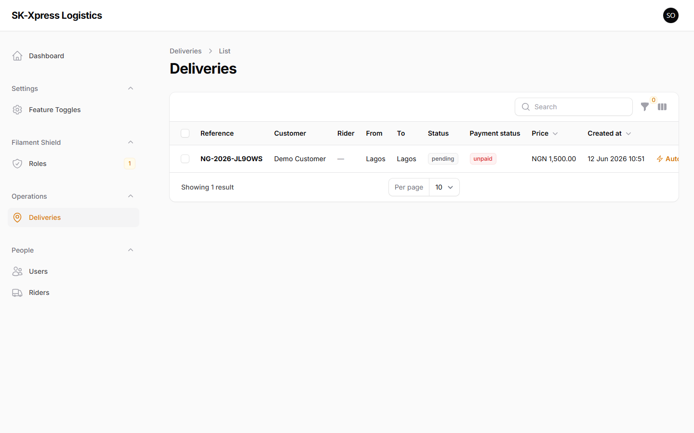
Delivery management — full oversight with rider-assignment controls.

Roles & Permissions
Create staff roles with precisely the access each person needs — protecting sensitive areas like payments and settings.
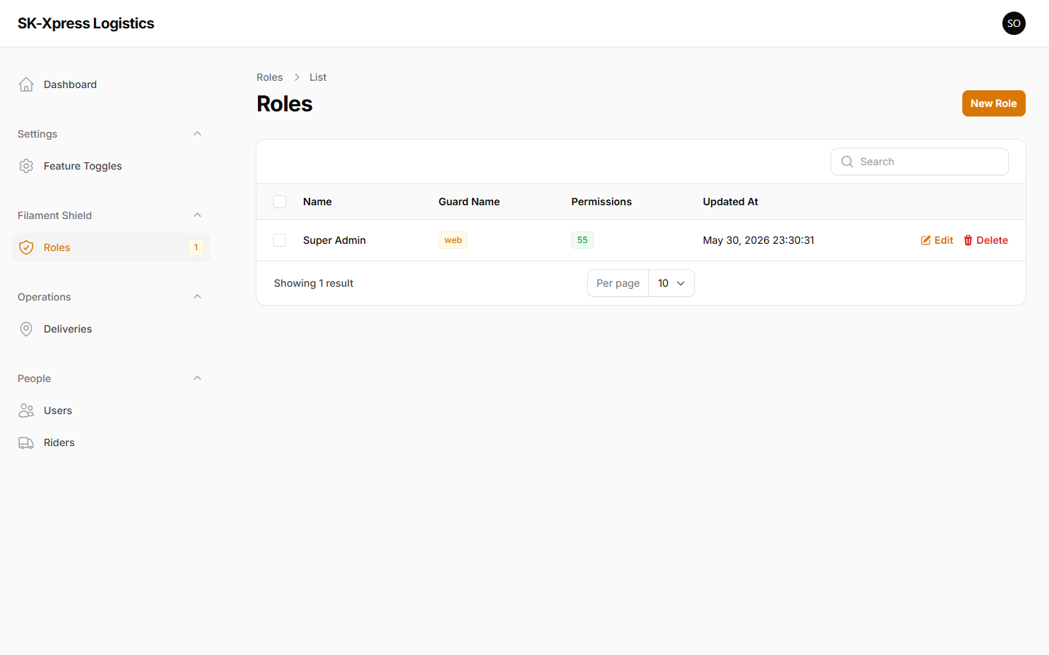
Roles & permissions — safe, controlled access for every team member.

Settings & Feature Controls
Switch platform features on or off in real time, with no technical help required.
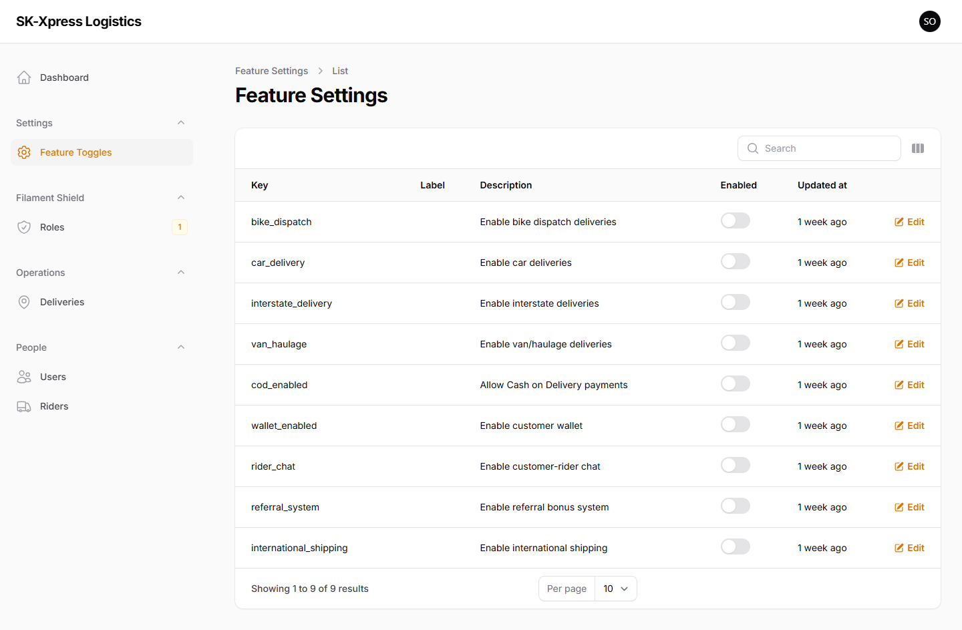
Feature controls — adapt the platform instantly without a developer.

Customer Website Overview
The customer-facing website is modern, fast, fully branded, and works on any device.

Homepage
A polished landing page that explains the service, builds trust, and turns visitors into customers.
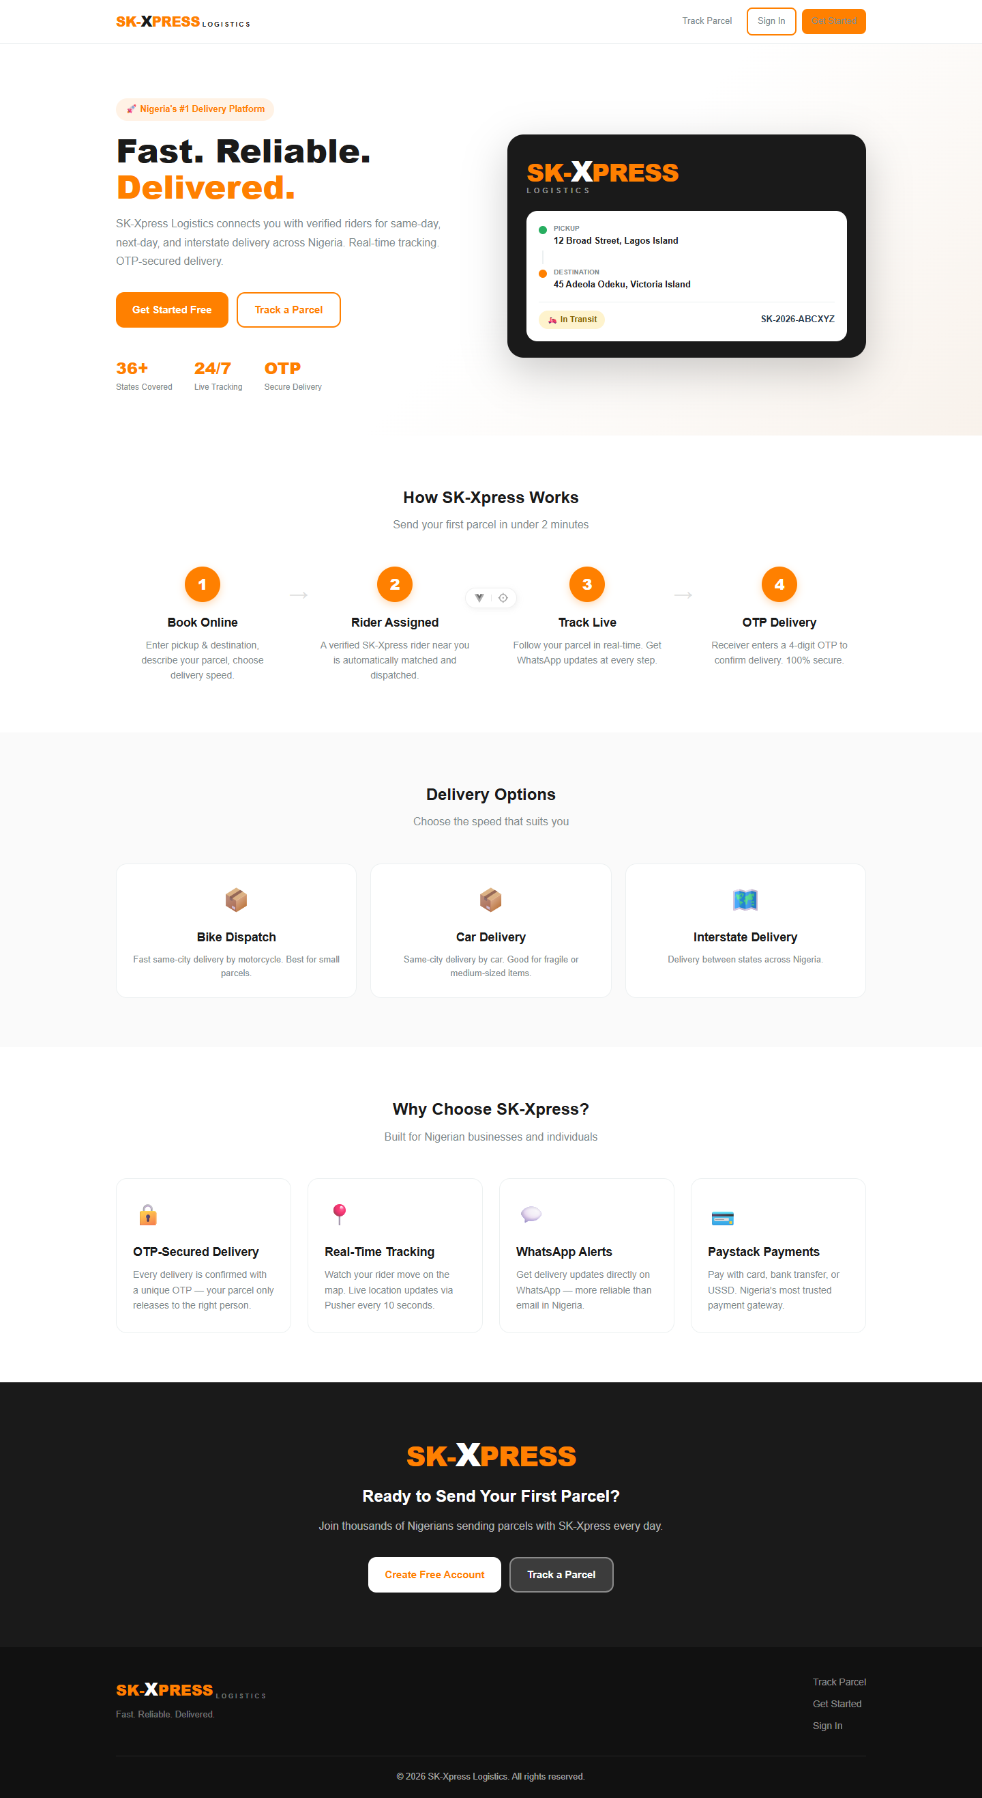
The homepage — a professional first impression that drives sign-ups.

Customer Dashboard
After signing in, customers get a personal dashboard with their delivery stats, active orders, and recent history.
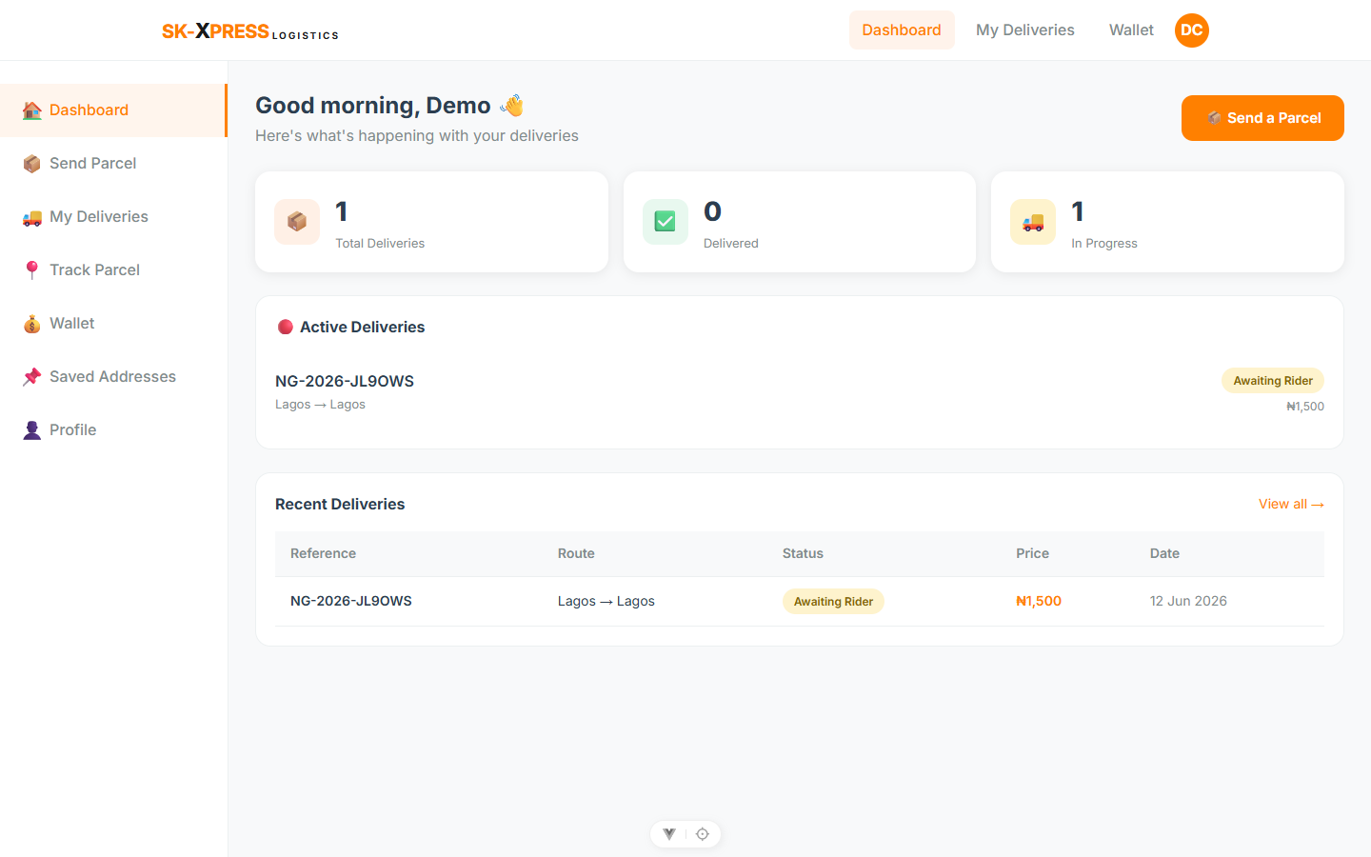
The customer dashboard — everything important in one view.

Booking a Delivery
A simple guided wizard walks the customer through booking, showing the price before they commit.
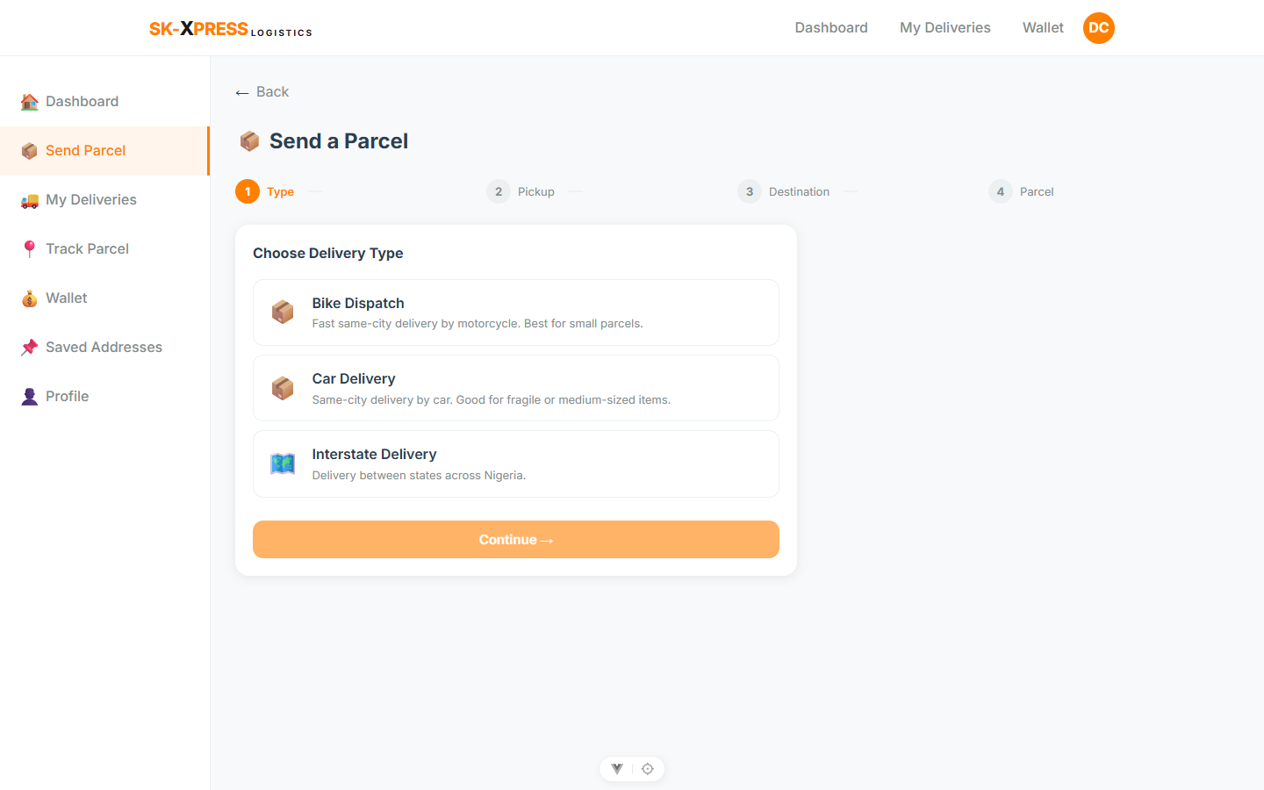
The booking wizard — fast, guided and error-proof.

Tracking a Delivery
A clear status screen and timeline show exactly where each parcel is.
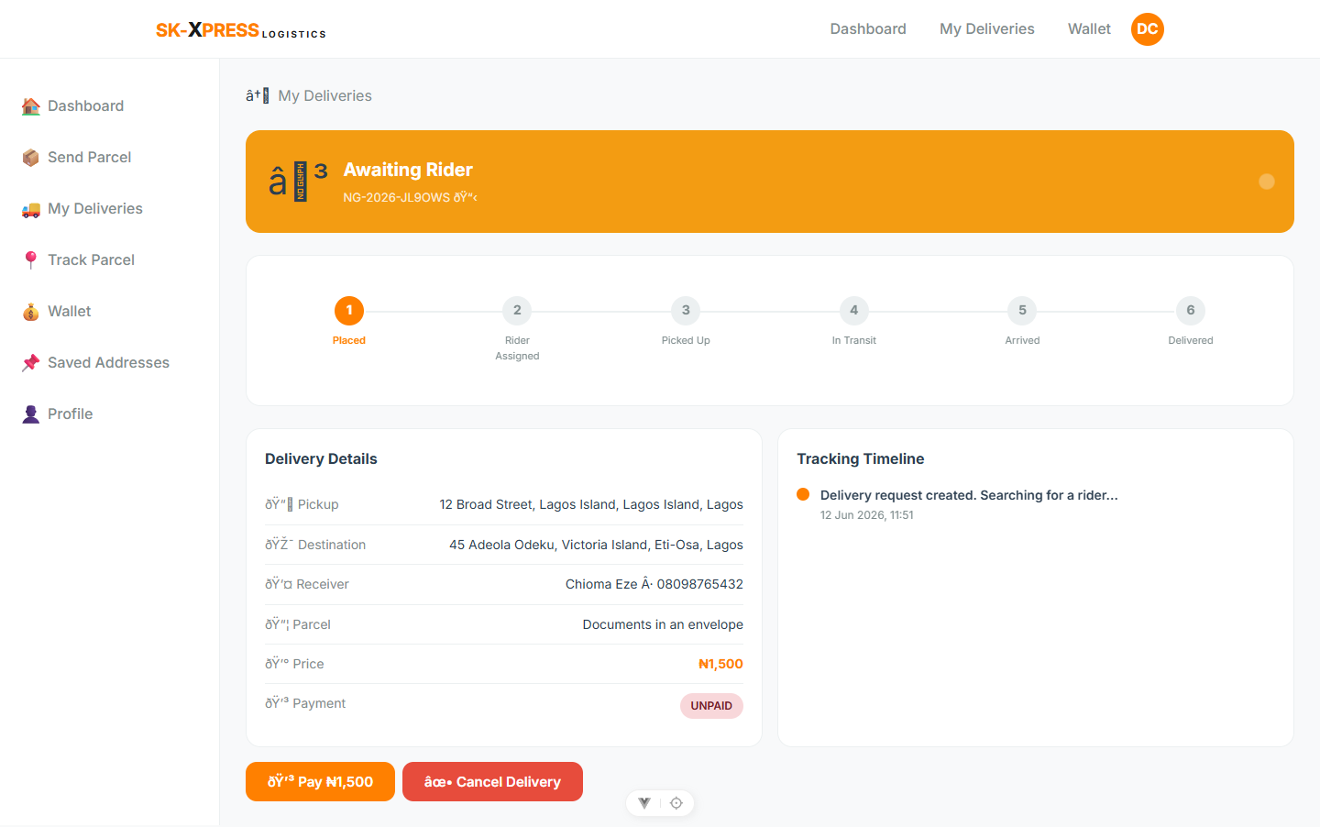
Delivery tracking — complete transparency on one screen.

Wallet & Payments
Customers fund a wallet and pay instantly, with a full record of transactions.
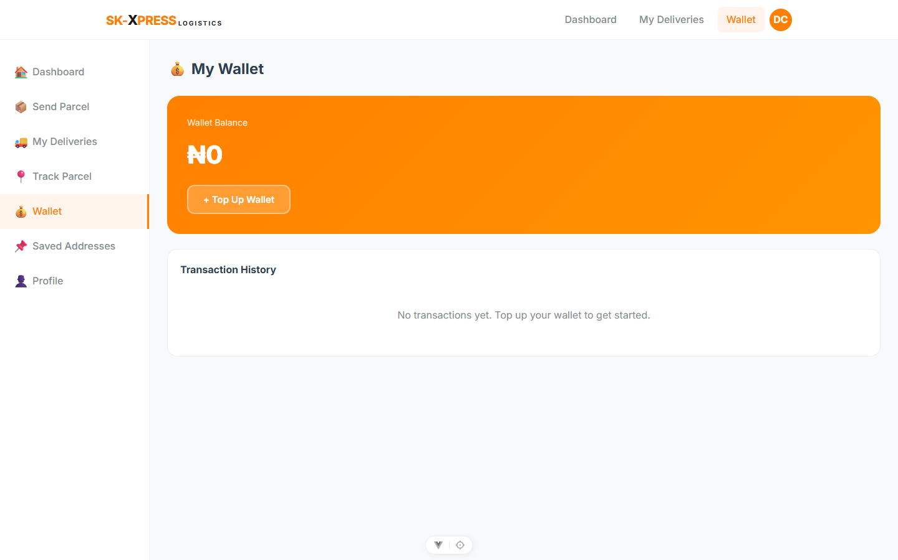
The wallet — trusted local payments and a clear transaction history.

Public Parcel Tracking
Anyone can track a parcel with just the reference number — no account needed — perfect for receivers.
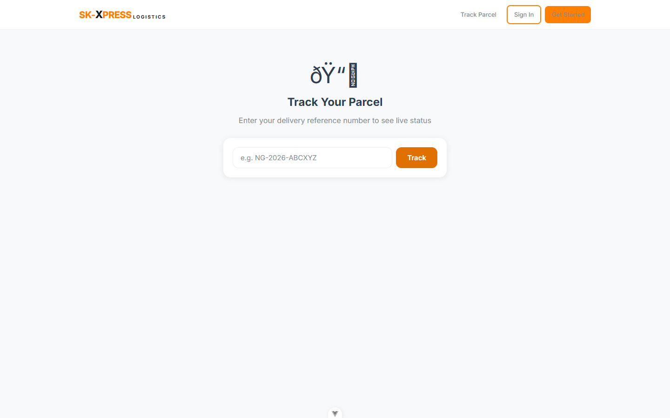
Public tracking — receivers follow a parcel without signing up.

Mobile Application Overview
SK-Xpress includes mobile apps for Android and iOS, giving customers and riders the full experience in their pocket — with push notifications and live GPS.
The screens below show the customer experience on a phone; the platform also includes a dedicated rider app with an online/offline switch, job alerts, and earnings.
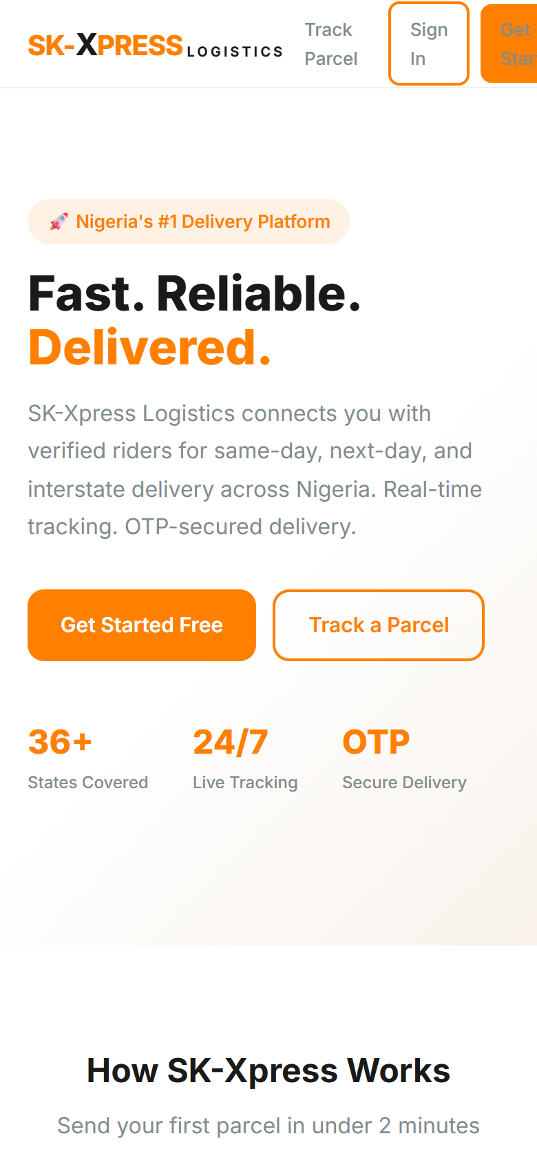  Mobile home | 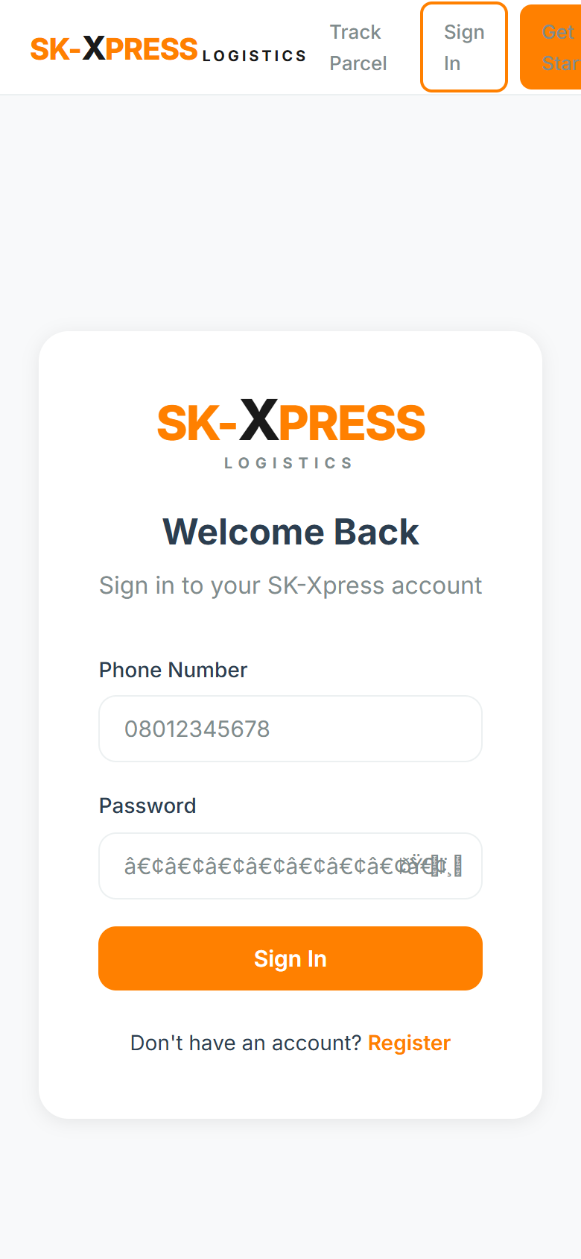  Mobile sign-in

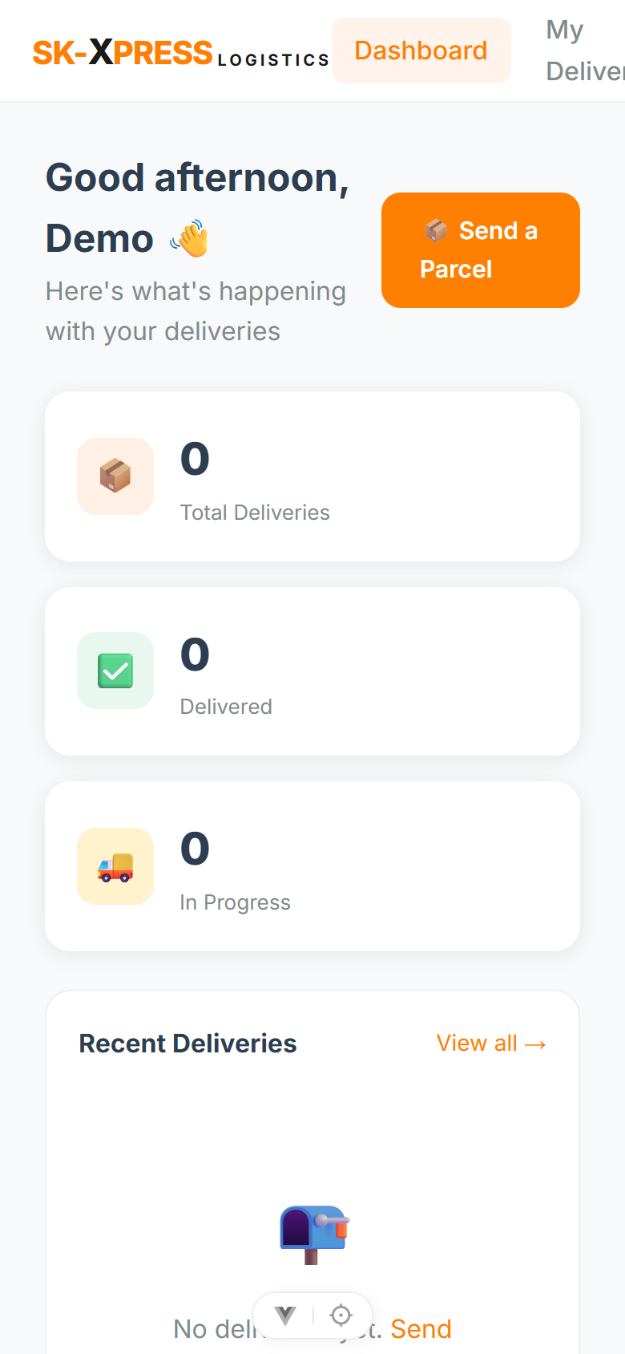  Mobile dashboard | 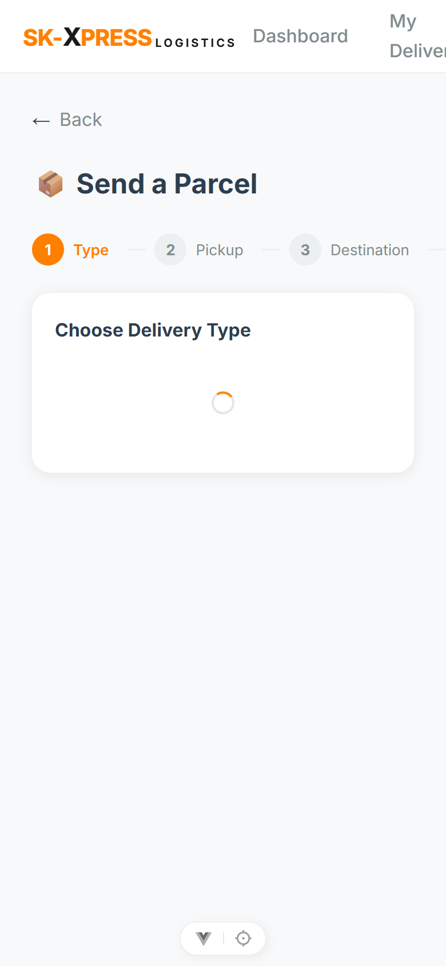  Booking on mobile

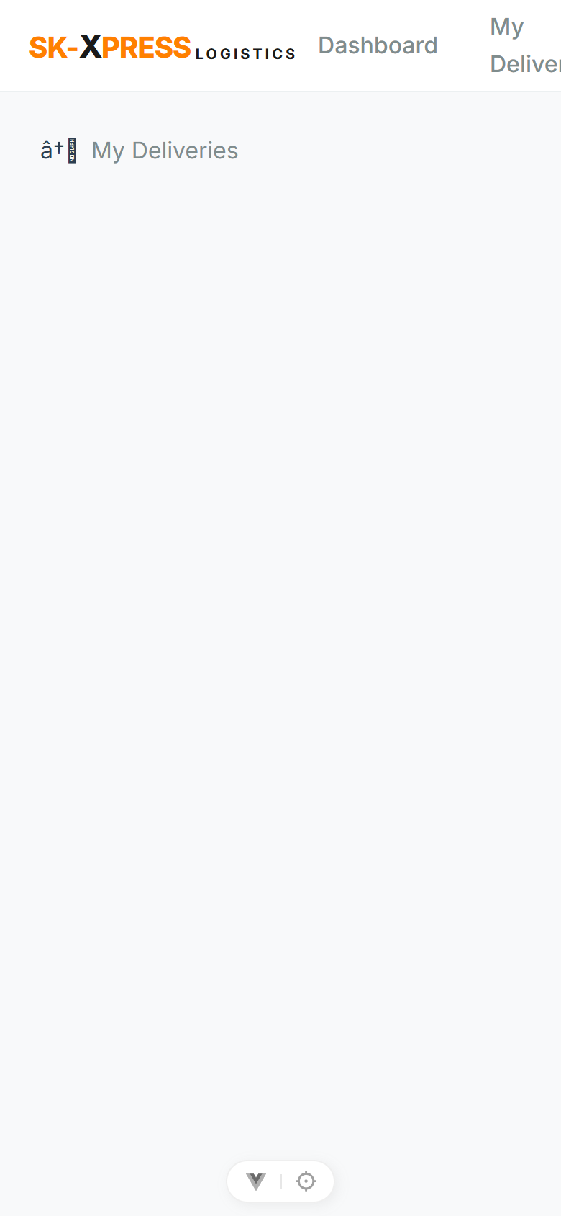  Live tracking | 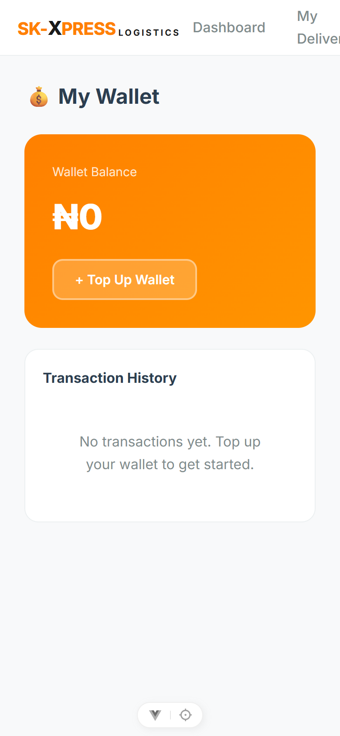  Mobile wallet

Why Buy This Software?
- It is complete and proven — A delivery business worth millions in development is ready to deploy today.
- It is a full ecosystem — website, mobile apps, and admin dashboard all included and connected.
- It is built for the local market — phone-first sign-up, local payments, WhatsApp updates, and full state/LGA coverage.
- It is cost-effective — runs on affordable shipping-grade shared hosting; no expensive infrastructure.
- It is scalable — the architecture is built to grow from a handful of riders to a large fleet.
- It is yours to brand — your name, your logo, your colours, your domain.

Return On Investment
SK-Xpress pays for itself quickly by replacing cost and unlocking revenue:
Value driver | How it pays back
Software development saved | Building this from scratch would cost many months and a large budget. You skip almost all of it.
Staff cost saved | Automation means fewer dispatchers and support staff for the same volume of orders.
Faster payment collection | Upfront card and wallet payments improve cash flow and reduce losses.
More completed orders | A smooth, trusted experience means more bookings and repeat customers.
Lower running costs | Affordable hosting and efficient operations keep monthly costs low.

Monetisation Opportunities
There are many ways to earn money with SK-Xpress:
- Delivery fees — charge customers for every parcel delivered, priced automatically.
- Commission on riders — take a percentage of each delivery as platform revenue.
- Express & priority services — offer guaranteed-time or premium delivery types at higher prices.
- Business subscriptions — charge businesses a monthly fee for high-volume or branded accounts.
- White-label resale — deploy and sell the platform to other delivery businesses as your own product.
- Advertising & partnerships — use the customer base and homepage to promote partner services.

Industries That Can Use This Software
SK-Xpress fits any business that needs to move items from one place to another:
- Courier & dispatch companies
- E-commerce & online stores
- Restaurants & food delivery
- Pharmacies & medical supplies
- Supermarkets & grocery
- Fashion & retail brands
- Document & logistics services
- Laundry & dry-cleaning pickup
- Spare parts & auto supplies
- Agricultural produce delivery
- Inter-state package movement
- Errand & personal-shopper services

Competitive Advantages
Everything in one package
- What it does: Website, mobile apps and admin dashboard are included and already work together.
- Why it matters: Competitors often sell only one piece and leave you to find the rest.
- Benefit: You get a complete business, not a building block.
Built for the local market
- What it does: Local payments, WhatsApp confirmation, phone-first sign-up, and full national coverage.
- Why it matters: Generic foreign software does not fit how business is done here.
- Benefit: It works the way your customers and riders already expect.
Security that builds trust
- What it does: One-time delivery codes, secure payments, and protected admin access.
- Why it matters: Trust is everything in delivery.
- Benefit: Fewer disputes and a stronger brand reputation.
Affordable to run
- What it does: Designed to work on standard shared hosting.
- Why it matters: You do not need an expensive technical setup.
- Benefit: A professional platform at a small-business price.

Frequently Asked Questions
Q1. Do I need to be technical to use this?
No. The admin dashboard is point-and-click. Day-to-day running needs no technical skill. Initial setup can be done by any web host or by SENUX Media.
Q2. Do I need an expensive server?
No. It runs on standard, affordable shared hosting with your own domain.
Q3. How long does it take to launch?
Setup typically takes well under an hour. After that you can start taking orders the same day.
Q4. Can I use my own brand?
Yes. The name, logo, colours and domain are all yours. White-labelling is fully supported.
Q5. Does it work in my country?
It is built for the African and Nigerian market, with full states and local-government coverage, but it can be adapted to other regions.
Q6. What payment methods are supported?
Cards, bank transfer and USSD through a trusted local payment gateway, plus prepaid customer wallets.
Q7. How do customers track deliveries?
On a live map with a step-by-step status timeline. Receivers can also track with just the reference number — no account needed.
Q8. How are deliveries kept secure?
The receiver gets a one-time code by WhatsApp that the rider must enter to confirm delivery.
Q9. How do riders get paid?
Each completed delivery automatically credits the rider their commission, with a transparent running total.
Q10. Can I control the delivery prices?
Yes. Pricing is fully configurable, and you can create different service types at different prices.
Q11. Can I have multiple staff with different access?
Yes. You can create roles so each staff member only sees what they should.
Q12. Is there a mobile app?
Yes — for both Android and iOS, covering customers and riders.
Q13. Do customers need the app to order?
No. They can use the website on any phone or computer; the app is an added convenience.
Q14. Can I see how my business is performing?
Yes. The dashboard shows live numbers, and every delivery, rider and payment is recorded.
Q15. What happens if a rider goes offline mid-delivery?
An admin can re-assign the delivery to another rider from the dashboard.
Q16. Can I turn features on or off?
Yes, instantly, from the settings — no developer needed.
Q17. Will it handle a growing business?
Yes. It is built to scale from a few riders to a large fleet.
Q18. Can I make money reselling it?
Yes. You can deploy it for other businesses as a white-label product.
Q19. Is my data safe?
Yes. Access is protected, payments are secure, and sensitive areas are permission-controlled.
Q20. Do I get the source code?
Yes. You receive the complete application so you fully own your platform.
Q21. Can it be customised?
Yes. SENUX Media offers customisation, new features and integrations on request.
Q22. What if I need help setting up?
SENUX Media provides deployment assistance and technical support.
Q23. Can I add more delivery types later?
Yes. New service types and pricing can be added at any time.
Q24. Does it send notifications automatically?
Yes. Customers receive automatic updates by WhatsApp and push notification at each stage.
Q25. How is this better than building my own?
Building from scratch costs months of time and a large budget. SK-Xpress gives you a finished, proven platform at a fraction of the cost and time.

Conclusion — Your Delivery Business, Ready to Launch
SK-Xpress Logistics is not a concept or a template — it is a complete, working delivery business in a box. The website, the mobile apps, the rider system, the payments, the tracking, and the admin dashboard are all built, connected, and ready.
For a dispatch company, it replaces chaos with automation and control. For an entrepreneur, it turns months of development into a single launch. For an investor, it is a proven, scalable platform in a fast-growing market.
Every day spent without it is a day of manual work, missed orders, and lost trust. With SK-Xpress, you can launch a professional, modern delivery brand — and start earning — almost immediately.
Fast. Reliable. Delivered.
Ready to make it yours?
Contact SENUX Media • business@senux.xyz
This product was designed and developed by SENUX Media. All rights reserved.

